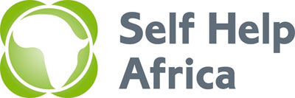 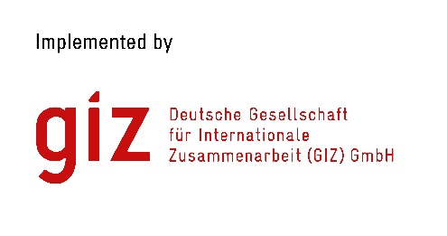 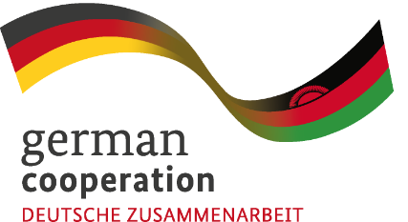

**JOIN OUR TEAM**

**PROJECT OFFICER - AGRIBUSINESS**

Self Help Africa (SHA) is an international NGO dedicated to the vision of an economically thriving and resilient rural Africa. We have 50 years of experience working with smallholder farmers and rural communities across Africa to help farmers grow and sell more food, improve their nutrition, diversify incomes and make their livelihoods more sustainable and resilient to external shocks. SHA has been active in Malawi since 1994, delivering enterprising solutions that help the rural poor recover from disasters, improve their food and livelihood security and support economic development. Our vision is an economically thriving and resilient rural Africa. Our mission is to support sustainable livelihoods for Africa’s smallholder farmers. Our values are: Equality – people are equal in rights and must be treated with respect and dignity. Innovation – we are conscious that finding effective solutions requires innovative thinking combined with a pragmatic approach. Learning – we strive for the highest quality standards in our work and encourage a culture of constant learning and improvement. Accountability – accountability and transparency are central to all our actions and use of resources.

Self Help Africa as lead agency, in collaboration with Total Land care and RUMARK, with funding from the GIZ, will be implementing a project called Capacity Development of Market Oriented Rural Enterprises (CADMORE). The purpose of this project is to improve agri-business profitability of 5,400 smallholder farmers organized in 180 Farmer Organizations (FOs) and 96 Micro, Small and Medium Enterprises (MSMEs) in Chitipa, Karonga, Mzimba and Nkhatabay Districts of Malawi. This project will work with existing FOs involved in the Soybean, Cassava and Groundnut value chains.

The incumbent will be responsible for ensuring that the targeted beneficiaries grow their business, develop their various entrepreneurial capacities and access sustainable markets. The incumbent should also be able to roll out Farmer Business Schools, Cooperative Business Schools, Agri – finance trainings and facilitate market linkages with ultimate beneficiaries.

**Minimum Requirements**

* A minimum of bachelor’s degree in Agribusiness, Agriculture economics, Enterprise Development, or related field.
* A minimum of 5 years proven work experience in Agri - business programming
* Ability to effectively participate and contribute to a multi-stakeholder project,
* Ability to facilitate technical meetings and processes effectively,
* Strong experience working on enterprise development and marketing,
* Strong background knowledge on group development and dynamics,
* Strength in interpersonal, communication, people management, problems solving, innovations, negotiation, and presentation skills,
* Fluency in both spoken and written English.
* Developed skills in capacity building, extension methods and skills transfer,
* Good ability to work in multi-sectoral teams, readiness to travel and work in rural areas,
* He/ She should possess a valid motorcycle riders license,
* He/she is expected to work 90% in the field and 10% in the office.

**Application Process**

Please submit by 5pm of 20th November, 2020 a completed application form, CV and motivation letter which can be downloaded at <https://selfhelpafrica.org.uk/category/careers/where> the detailed job descriptions can also be found.

Completed application forms, motivation letter, and an updated curriculum, for the vacancies should be submitted to [programmes.malawi@selfhelpafrica.org](mailto:programmes.malawi@selfhelpafrica.org)