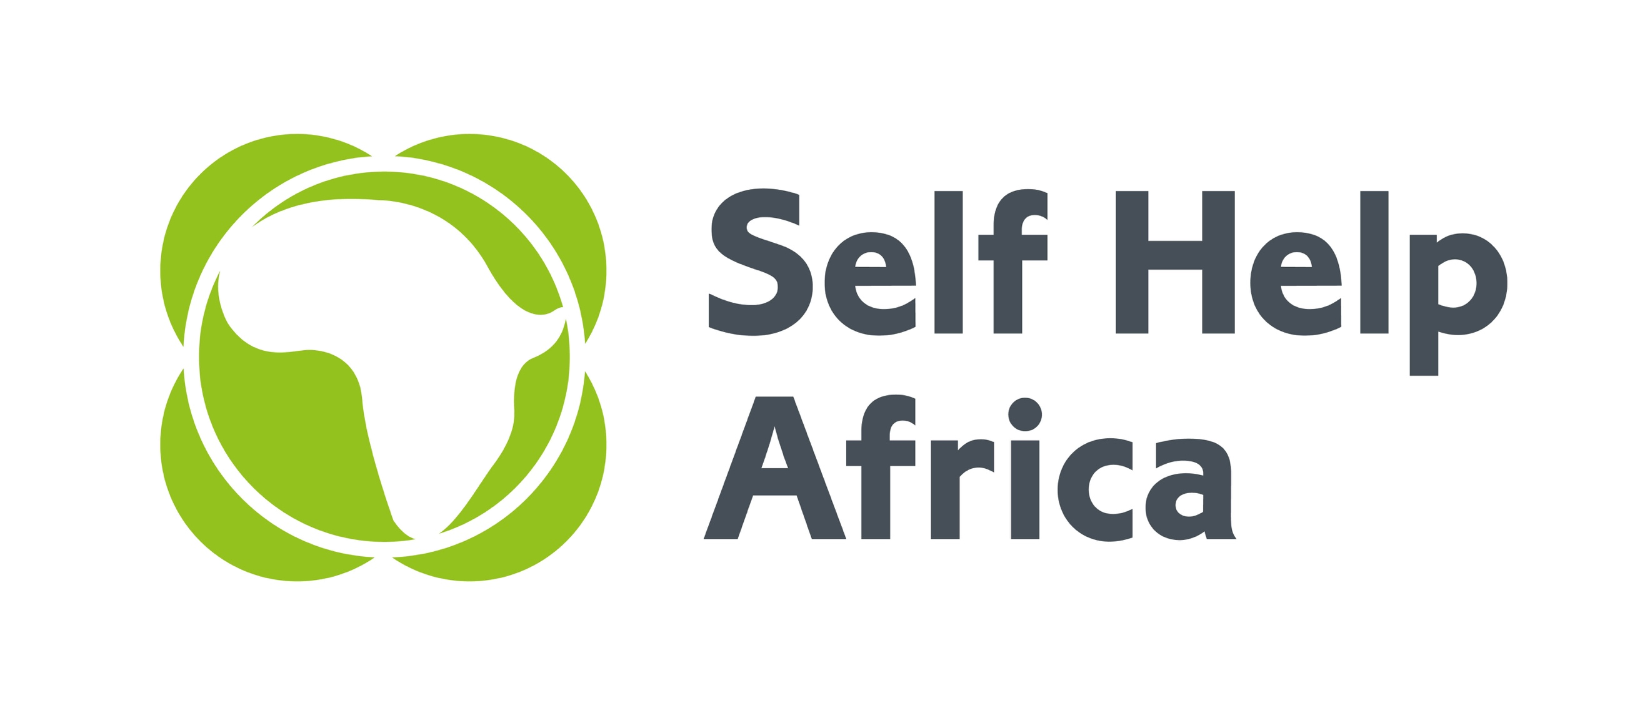

Kenyan Initiative for Long-term Integration of Market Operators in Value Chains (KILIMO – VC)

AgriFI Kenya Challenge Fund is a five-year agribusiness support programme that is part of the European Union’s Kenya-AgriFI programme that supports productive, adapted and market integrated smallholder agriculture, including a contribution to the Africa Investment Facility. The overall objective of the programme is to improve the capacity of 100,000 smallholder farmers/pastoralists to practise environmentally sustainable and climate-smart agriculture as a business in inclusive value chains. Self Help Africa (SHA) and Imani Development are the fund managers for the programme which aims to deliver:
- 10,000 net equivalent jobs within sustainable agri-enterprises
- A 70% increase in smallholder/ pastoralist production marketed
- At least 20,000 hectares under climate-smart land management practices.
- Increased turnover for at least 50 agri-enterprises
- Increased incomes for at least 100,000 smallholders/ pastoralists as agri-enterprises expand in their markets
Self Help Africa is an international Irish based NGO dedicated to the vision of an economically thriving and resilient rural Africa. We have 50 years of experience working with smallholder farmers, farmer associations, cooperatives and agribusinesses across Africa to help farmers grow and sell more food, improve diets, diversify incomes and make their livelihoods more sustainable and resilient to external shocks.

Portfolio Manager (1position)
The Portfolio Manager will be responsible for the management of the agri-enterprise portfolio assigned to him/her. This will include pipeline generation through networking, information sessions etc. The Portfolio Manager will also provide leadership in the project refinement for contracting for each company within his/her portfolio. She/He will monitor implementation progress, participate in M&E activities, conduct due diligence/capacity assessments, provide technical assistance and coaching to the portfolio of selected agri-businesses. Qualifications: At least five years’ experience in the implementation of agri-business/enterprise development projects with mentoring and support of Lead Firms/MSMEs within value chains or related projects, at a mid/senior level. Strong project management skills with an in-depth understanding of business decision-making in competitive market environments; inclusive subsector development and value chain/Market Systems Development. Strong analytical skills for appraising business case reports and audited financials with an understanding of performance contracting, follow-up, and execution. Bachelor’s degree in agribusiness, management, or economics required.

Monitoring & Evaluation Officer (1position)
The Monitoring & Evaluation Officer will be part of the AgriFI Kenya Challenge Fund team and will advise the Team Leader in planning, implementation and reporting of monitoring, evaluation and learning related activities of the Programme. S/He will contribute to the development of programme related M&E systems, tracking performance indicators, development of data collection tools, data collection, analysis and reporting, drafting of learning papers and thought leadership papers. Independently manage surveys through SHA specific methodologies and tools. Provides accurate analysis and presentation of information to enhance SHA’s position as a strong development partner. Qualifications: At least 3 years relevant working experience in Monitoring and Evaluation of donor funded Projects. Excellent knowledge and practice of project cycle management. Demonstrated skills in result-based M&E frameworks, indicator tracking, M&E systems development, Development of data collection tools and report writing and familiarity with database management and statistical analysis. Practical/ Field experience in data collection, analysis & data quality control. Bachelor’s degree in Agricultural Economics, Development Studies, Project planning & Management, Monitoring & Evaluation or other related discipline.

To Apply:
Download and complete the application form available from https://selfhelpafrica.org/uk/category/careers/ and email to infokenya@selfhelpafrica.net with your name and position applied for in the subject line.

The closing date for receiving applications is not later than Close of Business on Wednesday 24th July 2019.

Please do not send certificates at this stage.
Due to the anticipated high volume of applications, kindly note that only shortlisted candidates will be contacted.
Female candidates who meet these qualifications are highly encouraged to apply.

Self Help Africa is an equal opportunities employer and will never ask for funds as part of the recruitment process.
Report Fraud at https://wrs.expolink.co.uk/selfhelpafrica

