

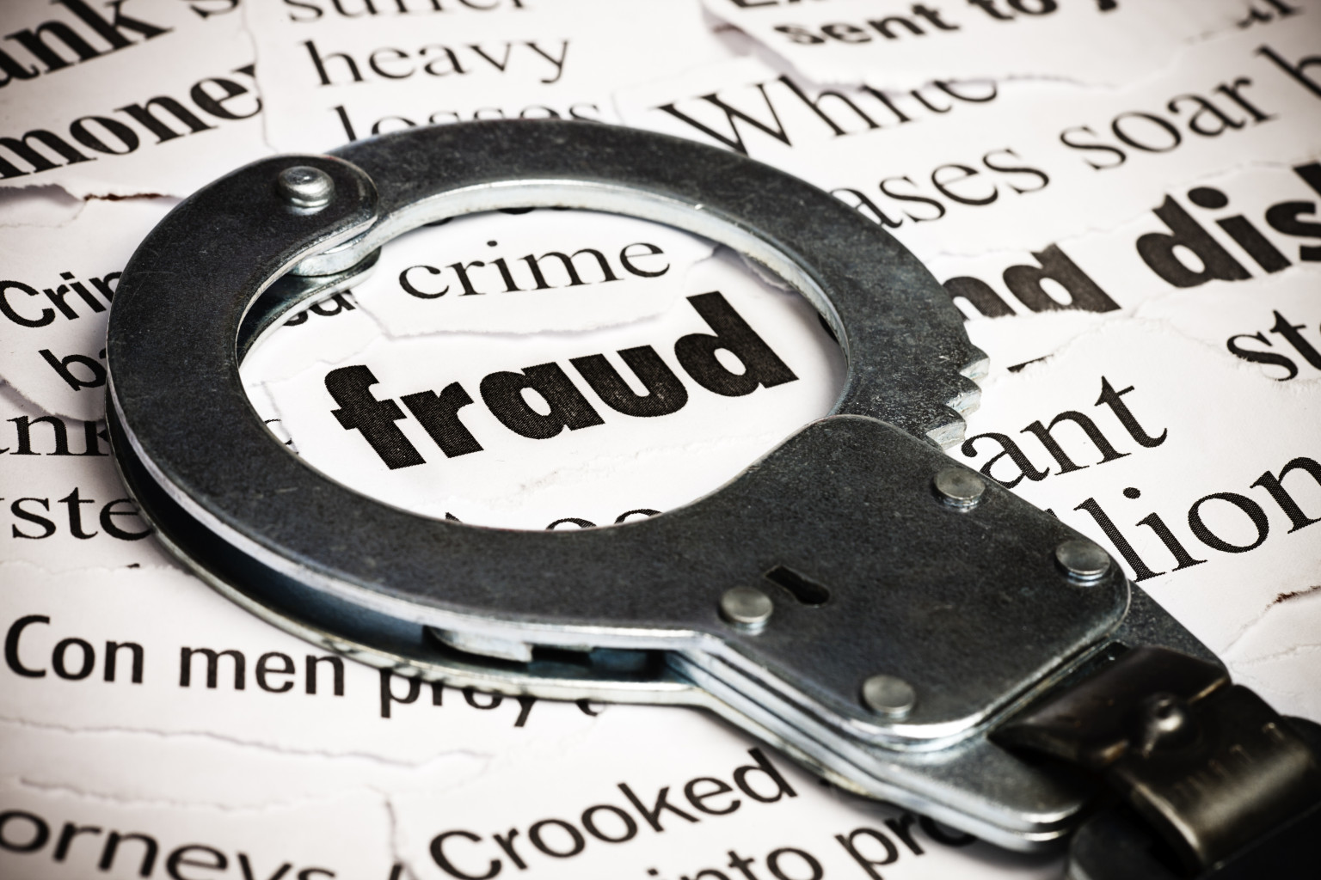

selfhelpafrica.org

Anti-Fraud Policy

2017

INTRODUCTION:

SELF HELP AFRICA is committed to acting professionally and fairly in all of its dealings and relationships, employing the highest standards of openness transparency and accountability.

SELF HELP AFRICA promotes a culture of honesty and

integrity, and totally opposes any form of fraud, bribery or corruption. Fraud, bribery and corruption impact disproportionately on the poor and the most vulnerable people in the

world. Such criminal activities divert resources intended for humanitarian assistance and development away from our intended beneficiaries; they increase the costs of basic public services; and undermine economic

growth. Such actions are a barrier to poverty alleviation and good governance.

The purpose of the SELF HELP AFRICA Anti-Fraud Policy is to provide clear definitions of what we mean by fraud, bribery and corruption. It is also a definitive statement to everyone associated with SELF HELP AFRICA - making clear that we will not tolerate fraudulent or corrupt activities, and the giving or receiving of bribes. This policy summarises the responsibilities of all SELF HELP AFRICA staff and Board members to adhere to and uphold SELF HELP AFRICA’s position on fraud, bribery and corruption. When we refer to SELF HELP AFRICA in the SELF HELP AFRICA Anti-Fraud Policy we mean SELF HELP AFRICA (International), SELF HELP AFRICA US Fund and all SELF HELP AFRICA subsidiaries, branches and/or liaison officers and other entities established in programme countries from time to time (all defined as “SELF HELP AFRICA”).

SELF HELP AFRICA’s Board(s) CEO and Senior Management Teams are committed to the implementation of this policy and to ensuring that training and support is provided to all employees and Board members on its content, and on their individual and collective responsibilities.

2. WHO THIS APPLIES TO

The SELF HELP AFRICA Anti-Fraud Policy applies to any person or entity that is associated with SELF HELP AFRICA. This includes the SELF HELP AFRICA Board and all SELF HELP AFRICA employees, whether part-time or full-time, and to all paid and unpaid consultants, contractors, interns, secondees and volunteers that provide services to SELF HELP AFRICA at any location in or out Ireland. “SELF HELP AFRICA Board” is employed as a collective term in this Policy in reference to the SELF HELP AFRICA Ireland Board, SELF HELP AFRICA UK Board and SELF HELP AFRICA US Board.

The SELF HELP AFRICA Anti-Fraud Policy will also to apply to SELF HELP AFRICA’s partners, vendors and other third parties where it is included or referenced in relevant bid or tender documents, agreements, memorandums, purchase orders, contracts, or where otherwise notified by SELF HELP AFRICA to a relevant party. Staff with responsibility for managing partnerships must ensure that this Policy is included or referenced in any agreements with partners.

3. DEFINITIONS

Fraud, bribery or corruption in any form will not be tolerated by SELF HELP AFRICA

3.1 What is Fraud?

Fraud is used to describe a range of illegal activities. These include, but are not limited to, deception, forgery, theft, the false reporting or concealment of material facts, collusion and corruption (including bibery) and undeclared conflicts of interest (please see SELF HELP AFRICA’s Conflicts of Interest Policy).

Examples of fraud other than bribery, include, but are not limited to:

* Theft of money, property or assets
* Inappropriate use of company assets
* Submitting false expense claims
* Forging, tampering with or falsely creating documents or records
* Destroying or removing documents or records
* Knowingly creating or distributing false financial information or reports
* Engaging in bribery or corruption
* Deliberately ignoring or acquiescing in fraudulent activity

3.2. What is Bribery & Corruption?

Bribery and corruption have a range of definitions in law. The following is a plain language guide.

Bribery: The offering, promising, giving, accepting or soliciting of money, gifts or other advantages in exchange for doing something illegal or breaching an employer’s trust.

Corruption: The abuse of entrusted power or influence for private gain.

The following are some examples of attempted bribery:

* A potential supplier offers money or a gift to influence a procurement/tender process.
* A job applicant offers payment or a gift to increase his/her chances of being hired.
* A gift (e.g. excessive hospitality) offered to a local official in return for approving a proposal.
* A potential or actual beneficiary offers a payment in return for allowing him/her or their family to be given aid to which they are not entitled.
* A government official asks for a payment to secure an NGO registration.
* A customs official asks for an unofficial payment or gift to release goods.

3.3. What is a Facilitation Payment

The final two bullets above could be examples of facilitation payments, which are usually a bribe in the form of a small, unofficial payment. It is made to secure or expedite the performance of a routine or necessary action to which the person making the payment has legal or other entitlement, e.g. an unofficial payment made to a border guard/officer in return for a speedier crossing.

3.4. Kickbacks?

Kickbacks are typically payments made in return for a business favour or advantage.

* 1. Payments under Duress?

Payments made under duress are in response to demands accompanied by threats to life, limb or liberty.

3.6. What are ‘Gifts and Hospitality?’

These can range from small gifts or promotional materials (such as diaries and pens) to expensive hospitality (such as a holiday). Extravagant gifts and hospitality may be thinly-veiled bribes intended to induce improper behaviour.

4. POLICY STATEMENT

Fraud, bribery or corruption in any form will not be tolerated by SELF HELP AFRICA. Where criminality occurs the loss is not just to SELF HELP AFRICA but, much more importantly, to SELF HELP AFRICA’s beneficiaries who are some of the poorest vulnerable people in the world. It may also have a major impact on SELF HELP AFRICA’s reputation and, as a consequence, donor confidence in SELF HELP AFRICA.

This, again, ultimately impacts upon our beneficiaries. SELF HELP AFRICA will conduct, manage, and monitor all aspects of our work in a way that reduces and hopefully eliminates opportunities for fraudulent or corrupt activity, including the giving or accepting of bribes.

Facilitation Payments and ‘Kickbacks’?

All SELF HELP AFRICA employees and SELF HELP AFRICA Board members must avoid any activity that might lead to a facilitation payment being made or accepted by or on behalf of SELF HELP AFRICA. SELF HELP AFRICA prohibits the making or accepting of facilitation payments and ‘kickbacks’. If someone suspects a payment request to be solely for the purposes of facilitation, they should ask that a detailed receipt be provided. If there appears to be no legitimate reason for a request for payment, it should be explained that SELF HELP AFRICA does not make or accept facilitation payments. If a SELF HELP AFRICA employee feels it is safe and appropriate to do so, they should ask to speak to the supervisor of the person requesting the payment. If a receipt can be provided and the SELF HELP AFRICA employee does not suspect the payment is for the purposes of facilitation, a payment will be allowable.

Payments under Duress

It is permissible for a payment to be made in the rare and exceptional circumstances where it is believed necessary to protect against loss of life, limb or liberty (except in the case of lawful detention). If possible, the circumstances and proposed payment should be discussed in advance with a line manager. In all such cases an incident report must be submitted, as per the SELF HELP AFRICA Security Policy.

Gifts & Hospitality

The giving or receiving of gifts (other than those deemed to be small promotional items) by or on behalf of SELF HELP AFRICA is not permitted under any circumstances. SELF HELP AFRICA staff and Board members must exercise great caution when offering or accepting hospitality and entertainment. They must be certain that what is being offered is not designed to gain improper benefit, or does not otherwise amount to bribery or corruption.

The providing or accepting of hospitality or entertainment is allowed, as long as:

* It is not done with the intention of influencing the behaviour of the recipient;
* 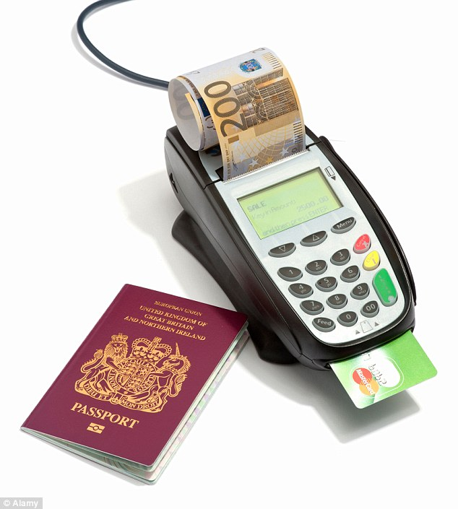It is done openly;
* It complies with local law.

If a member of SELF HELP AFRICA staff or Board wishes to offer entertainment or hospitality, it must be authorised by a senior manager in advance.

5. RESPONSIBILITIES

SELF HELP AFRICA Board members, Senior Management, Managers and employees at every level are responsible for protecting SELF HELP AFRICA and the communities we serve from the impact of fraud, bribery and corruption by always acting in accordance with this policy.

5.1 Board of Directors

The SELF HELP AFRICA Board of Directors is responsible and accountable for ensuring that the organisation is performing well and complying with all of its obligations.

5.2. Senior Staff & Managers

It is incumbent upon SELF HELP AFRICA managers and senior staff to set an example by complying fully with SELF HELP AFRICA’s policies, procedures and controls. Managers and senior staff are responsible for ensuring that employees under their charge are trained upon and fully understand the SELF HELP AFRICA Anti-Fraud Policy, and the consequences of non-compliance.

Senior staff and managers should be familiar with and alert to the types of fraud that might occur in their area(s) of responsibility. In particular they should:

* Ensure that this policy and all SELF HELP AFRICA’s systems, financial controls and procedures are fully understood by staff;
* Frequently check that these are being fully observed and implemented;

Regularly review and, where necessary, update control and procedures.

5.3. All Employees

It is the responsibility of every SELF HELP AFRICA employee to carry out their work and conduct themselves at all times in such a way as to prevent fraud, bribery and corruption. All SELF HELP AFRICA employees and Board members must be alert to and report any actual or suspected instances of fraud, bribery and/or corruption.

5.4. Responsibility of the Organisation

Periodic Risk Assessments: The SELF HELP AFRICA Audit and Risk Committee (ARC) shall regularly (at minimum, once a year) assess risks, including those covered by this policy; assess, update and record existing and potential risks to the organisation’s human and material assets.

6. REPORTING

If someone connected to SELF HELP AFRICA is offered or asked to pay a bribe, they must refuse and explain that bribery runs totally counter to SELF HELP AFRICA policies. If someone suspects that fraud, bribery or corruption is, has, or is likely to take place, they should at the earliest opportunity report the matter via the SELF HELP AFRICA Whistleblowing Policy. The interests and well-being of those making a report will be fully protected by SELF HELP AFRICA’s Whistleblowing Policy.

Failure on the part of a SELF HELP AFRICA employee or Board member to report suspicions may lead to disciplinary procedures being instigated, up to and including dismissal and/or legal proceedings. If an employee knowingly lodges a false report, this will be regarded as a serious disciplinary offence and dealt with in accordance with SELF HELP AFRICA’s disciplinary procedures.

7. TRAINING AND COMMUNICATION

As part of the induction given to new staff and Board members to any SELF HELP AFRICA entity, SELF HELP AFRICA will effectively communicate and provide training on our Anti-Fraud Policy. Ongoing refresher courses and training on anti-fraud will also be conducted.

8. ANNUAL APPRAISAL

Completion of training on anti-fraud and ensuring that senior staff (and those under their charge) are

compliant with this policy will form part of SELF HELP AFRICA’s annual performance appraisals.

9. DISCIPLINARY SANCTIONS

Violations of this policy will be dealt with in accordance with SELF HELP AFRICA’s Disciplinary Procedure and may result in sanctions, up to and including termination of employment.

10. ASSOCIATED POLICIES AND PROCEDURES

The SELF HELP AFRICA Anti-Fraud Policy is linked to and must be read in conjunction with:

* SELF HELP AFRICA Whistleblowing Policy
* SELF HELP AFRICA Code of Conduct
* SELF HELP AFRICA Conflict of Interest Policy
* SELF HELP AFRICA Security Policy and Crises Management Plans

*SELF HELP AFRICA reserves the right to report any suspected criminal activity to the relevant legal authorities.*



Self Help Africa

Kingsbridge House

Parkgate Street

Dublin

D08 NRP2 | Ireland

Tel: +353 1 6778880

E-mail: info@selfhelpafrica.org

Web: www.selfhelpafrica.org