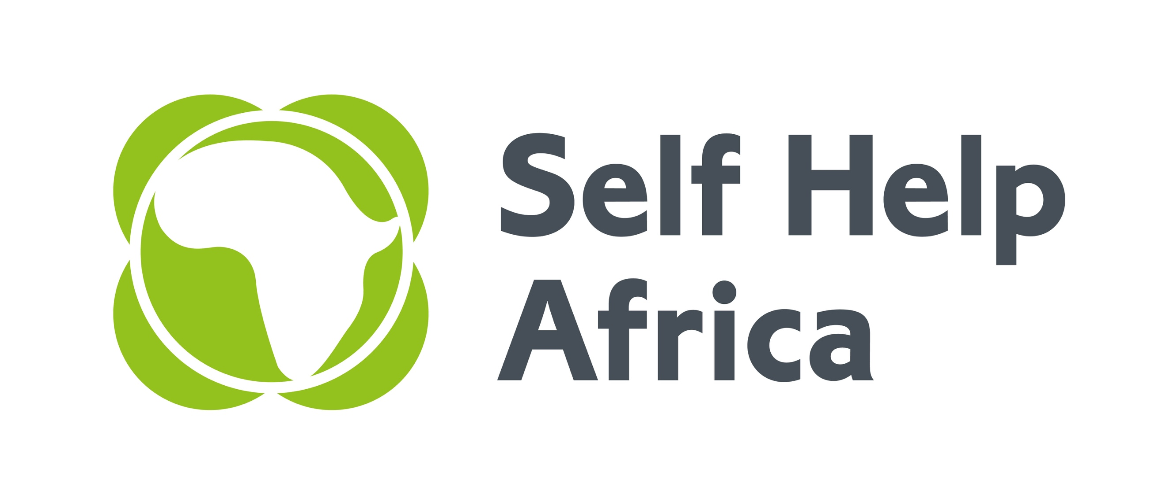
Self Help Africa is seeking an energetic and dynamic team to oversee the implementation of an ambitious new agribusiness development project implemented in partnership with and Imani Development Limited in Kenya.

Kenyan Initiative for Long-term Integration of Market Operators in Value Chains (KILIMO – VC)

KILIMO-VC is a EUR 24m five-year agribusiness support programme that is part of the European Union’s Kenya-AgriFI programme that supports productive, adapted and market integrated smallholder agriculture, including a contribution to the Africa Investment Facility. The overall objective of the KILIMO-VC programme is to improve the capacity of 100,000 smallholder farmers/pastoralists to practise environmentally sustainable and climate-smart agriculture as a business in inclusive value chains. Self Help Africa (SHA) and Imani Development are the fund managers for the programme which aims to deliver:
- 10,000 net equivalent jobs within sustainable agri-enterprises
- A 70% increase in smallholder/ pastoralist production marketed
- At least 20,000 hectares under climate-smart land management practices.
- Increased turnover for at least 50 agri-enterprises
- Increased incomes for at least 100,000 smallholders/ pastoralists as agri-enterprises expand in their markets
- 90,000 households with increased dietary diversity and decision-making power of female farmers
Self Help Africa is an international NGO dedicated to the vision of an economically thriving and resilient rural Africa. We have 50 years of experience working with smallholder farmers, farmer associations, cooperatives and agribusinesses across Africa to help farmers grow and sell more food, improve diets, diversify incomes and make their livelihoods more sustainable and resilient to external shocks.

Programme Manager/Team Leader
The Programme Manager is the technical and operational head of the KILIMO-VC Implementation Unit. Reporting to the Head of Programmes, the Programme Manager will be responsible for ensuring successful implementation of this 5-year, European Union-funded programme through providing strategic leadership, technical oversight and direct management of all activities related to the programme – in particular a EUR 18m challenge fund. A key function of the role will be managing effective partnerships with the Lead Firms/implementing organisations. This is a challenging leadership role within Self Help Africa-Kenya for a highly committed and results-orientated person with excellent organisational and communication skills, as well as enthusiasm and initiative. Qualifications: At least 10 years’ experience in the implementation of agri-business/enterprise development projects, five of which working with Lead Firms/MSMEs within value chains in a senior/executive role. Master’s degree in agribusiness, management, economics or related field required with in depth knowledge of agricultural finance, banking, investment/project appraisal and market systems development approaches.

Portfolio Managers (2positions)
The Portfolio Managers are responsible for providing technical assistance and coaching to a portfolio of selected applicants under the KILIMO-VC Programme. These value chain partnerships will cover a mix of Micro, Small and Medium Enterprises (MSME’s) including cooperatives. Reporting to the Programme Manager, the Portfolio Managers will provide technical assistance in the preparation of business plans, marketing and business development strategies and monitoring implementation. This position requires a highly committed and results-orientated person with excellent organisational and communication skills, as well as enthusiasm and initiative. Qualifications: At least five years’ experience in the implementation of agri-business/enterprise development projects with mentoring and support of Lead Firms/MSMEs within value chains or related projects, at a mid/senior level. Strong project management skills with an in-depth understanding of business decision-making in competitive market environments; inclusive subsector development and value chain/Market Systems Development. Strong analytical skills for appraising business case reports and audited financials with an understanding of performance contracting, follow-up, and execution. Bachelor’s degree in agribusiness, management, or economics required.

Monitoring & Evaluation Assistant (2positions)
The Monitoring & Evaluation Assistant works with the SHA M&E Coordinator to ensure effective planning, implementation and reporting of monitoring, evaluation and learning related activities The Monitoring & Evaluation Assistant will be responsible for developing programme related M&E systems, building the capacity of staff and implementing partners, communicating M&E information, documentation and reporting related to the KILIMO-VC programme. Qualifications: At least 3 years relevant working experience in Monitoring and Evaluation in a donor funded Project. Excellent knowledge and practice of project cycle management. Demonstrated skills in result-based M&E frameworks, indicators tracking, M&E systems development, Development of data collection tools and report writing and familiarity with database management and statistical analysis. Practical/ Field experience in data collection, analysis & data quality control. Bachelor’s degree in Agricultural Economics, Development Studies, Project planning & Management, Monitoring & Evaluation or other related discipline.

Communications Officer
The Communications Officer will serve as an integral member of the KILIMO -VC team and will be responsible for creating and implementing our communications strategies. S/he will be required to promote our brand in creative ways, interact with the media and establish trusting relationships with key stakeholders including the media outlets, partners and policymakers. Qualifications: Bachelor of Arts Degree in Applied Communications, Journalism and Mass Communication or any other related field. A minimum work experience of three (3) years in a similar position with strong applied skills on publishing, photo/video editing software. Excellent written and oral communication skills (English).

Project Accountant
The Programme Accountant will provide financial management by ensuring accurate and timely recording of financial data, processing of transactions and monitoring programme costs against donor guidelines, preparing financial reports and building capacity in partners. The Programme Accountant will maintain a high standard of accounting and financial control to ensure compliance with EU regulations. Qualifications: Five years practical experience in Financial Accounting, at least three of which should be in grants management. Internationally recognised accounting qualification or quality management qualification (CA, ACCA, CIMA, CPA) is required along with up-to-date knowledge of Generally Accepted Accounting Principles. Demonstrated experience donor fund projects and contracts, training and supporting staff and undertaking risk assessments, internal audits and/or assessing internal controls.

Programme Support Assistant
The Programme Support Assistant will provide administrative support to the KILIMO VC team. S/he will be responsible for managing all administrative and logistics activities of the project. S/he will also support the country team in procurement. The Programme Support Assistant will show initiative, be capable to meeting deadlines, be flexible, honest, diligent, innovative and be a team player. Qualifications: Diploma in Procurement and Supply Chain Management, Business/Operations Management or its equivalent experience of administration, logistics and procurement management with an International Non-Governmental Organisations. Basic knowledge of financial processes / bookkeeping is an added advantage.

To Apply:
Download and complete the application form available from https://selfhelpafrica.org/uk/category/careers/ Completed forms, with a cover letter, should be returned to infokenya@selfhelpafrica.net with your name and position applied for in the subject line.

The closing date for receiving applications is not later than Close of Business on Wednesday 7th February 2018.

Please do not send certificates at this stage. Due to the anticipated high volume of applications, kindly note that only short listed candidates will be contacted.

Self Help Africa is an equal opportunities employer

