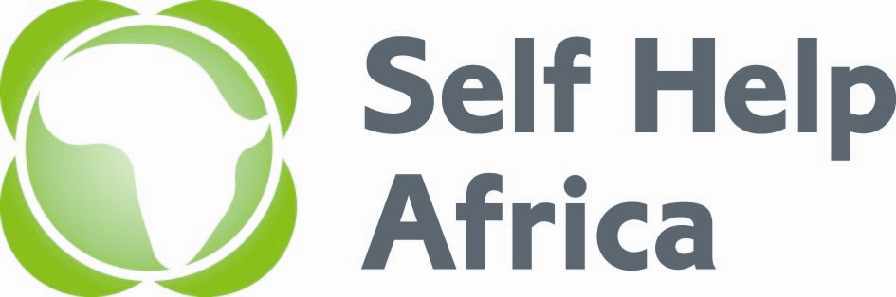

Job Advert - Programme Coordinator – Nutrition and Gender

Self Help Africa (SHA) is an International non-profit organization implementing food security and livelihood programs in rural Zambia. SHA’s mission is to develop enterprising solutions that enable smallholder farmers to achieve a better quality of life. Self Help Africa (SHA) Zambia Country Programme would like to recruit a Programme Coordinator – Nutrition and Gender who will be responsible for provision of technical support on Nutrition and Gender as well as ensuring effective mainstreaming of all related cross-cutting themes across the Zambia Country Programme.

Duties
The Nutrition and Gender coordinator will be required to;
- Contribute to the designing and planning of programmes; ensuring that nutrition, Gender and HIV and AIDS are adequately addressed with effective implementation strategies in line with Self Help Africa Zambia Country Programme strategy,
- Develop and carry out ongoing review of nutrition, Gender and HIV and AIDS policies/guidelines and strategies that provide strategic direction during planning, implementation, monitoring and evaluation across the Zambia Country Programme,
- Ensure effective and efficient mainstreaming of nutrition, Gender and HIV and AIDS issues across the programme and ensure development of appropriate tools for staff and partners for effective programme implementation,
- Establish knowledge gaps and specific learning needs of staff around Nutrition, Gender and HIV and AIDS across the programme and coordinate staff and partner capacity building for effective programme implementation,
- Guide processes of identifying Nutrition, Gender and HIV and AIDS -based advocacy issues and facilitate policy advocacy engagements at local and international levels for the implementation of nutrition, gender sensitive policies and laws and HIV and AIDS.
Required relevant Qualifications and Experience:
- Minimum of Bachelor’s Degree in Social / Health Sciences; Public Health; Nutrition/HIV and AIDS, Gender or related disciplines.
- At least 5 years working experience of which two should be in a management of nutrition, HIV and AIDS or gender programme.
- Experience and knowledge in the design and implementation of nutrition, Gender, HIV and AIDS projects within food and livelihoods setting for individuals or groups, especially smallholder farmers,
- Good knowledge and understanding of key aspects of development work; including food, nutrition and livelihood security, cross-cutting themes (e.g. gender, environment, HIV/AIDS),
- Strong skills in speaking and writing English with solid computer skills in Microsoft Word, Excel, power point and email,
- For more details on the roles and responsibilities and application process log on to: https://selfhelpafrica.org/uk/programme-coordinator-nutrition-gender/

Closing date for applications is 15th April 2016.

