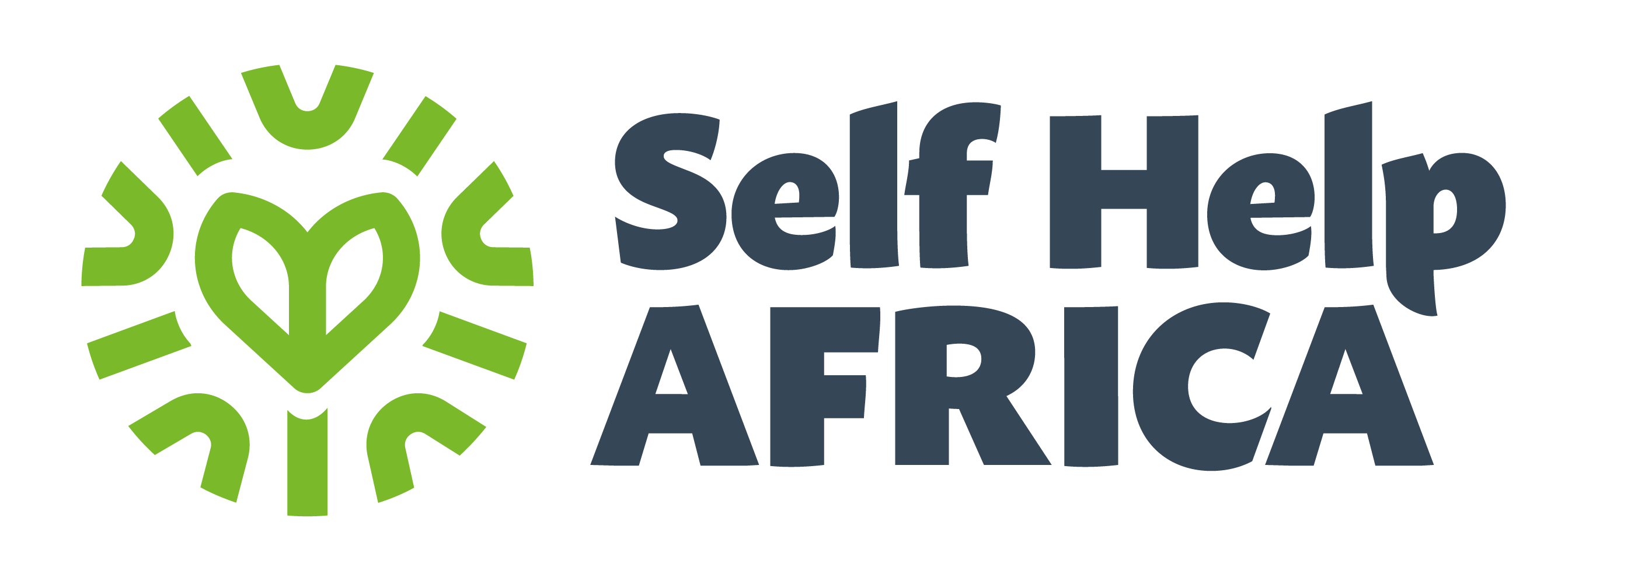

JOB DESCRIPTION
Job Title: | People, Culture and Facilities Administrator
Company: | Self Help Africa
Location: | Ireland
Department: | People and Culture
Reports to: | Interim Head of People and Culture
Organisation overview: | Self Help Africa is an international NGO dedicated to the vision of sustainable livelihoods and healthy lives for all in a changing climate. Headquartered in Ireland, with offices in the UK, the US, and Sub-Saharan Africa. SHA’s mission is the alleviation of hunger, poverty, social inequality and the impact of climate change through community-led, market-based and enterprise-focused approaches, so that people can have access to nutritious food, clean water, decent employment and incomes, while sustaining natural resources.
Job Purpose: | The purpose of this role is to provide cover on a six month fixed term contract.  Working closely with the People and Culture team, the People, Culture and Facilities Administrator will be part of the global People and Culture team and they will provide high calibre day to day support across the organisation.  The role will oversee day to day People and Culture operations at HQ level including travel and facilities management.
Key Responsibilities: | People and Culture Coordination  - Facilitate the end-to-end recruitment processes for designated roles across the organisation.  - Support the onboarding process for new joiners.  - Preparation of reports and metrics for People and Culture Team.  - Ensure all day-to-day P&C administration, to include preparation of documents, is delivered.  - Effectively ensure the P&C database is accurately maintained.  - Assisting with Employee Relations cases as required.  - Support the maintenance and updating of P&C policies, guidelines, and processes.  - Support the coordination, administration and organisation of wellbeing initiatives.  - Support monthly payroll administrative processes.  - Coordinate the set-up and administration of employee engagement initiatives.  - This role will require the incumbent to provide ad hoc administration assistance as required.  Facilities & Office Coordination  - Assist HQ staff when travelling overseas with travel logistics, including booking flights and accommodation.  - Management of facilities operations in Ireland and UK.
Key Relationships: | Internal  - Interim Head of People and Culture  - People and Culture Team  - Self Help Africa’s staff across Ireland and UK  External  - Partners (NGOs, private sector, etc)
Knowledge, Experience and Other Requirements | Essential  - Diploma/Degree Qualification in Human Resource Management and/or CIPD certification  - Minimum one-year administrative experience, preferably in a HR setting.  - Knowledge in recruitment and/or employment law.  - Excellent interpersonal and organisational skills.  - Ability to manage varied tasks simultaneously, working effectively as a team member and on own initiative.  - Excellent written and verbal communication skills.  - Good knowledge of MS Office suite and database systems.  - Ability to be discreet and discern when confidentiality is required.  - Good IT skills with a high level of accuracy and attention to detail.  Desirable  - Experience working in the NGO sector an advantage, but not essential.

Self Help Africa is an Equal Opportunities Employer
Important information:

Self Help Africa is an international development charity and is committed to the safeguarding of all those who we come into contact with or through our work. We are committed to preventing any type of unwanted behaviour relating to our work including sexual harassment, exploitation and abuse, lack of integrity and financial misconduct; and we are committed to promoting the welfare of children and the people we aim to assist with whom Self Help Africa engages. Self Help Africa expects all staff and volunteers to share this commitment and uphold the values and behaviours outlined in the Code of Conduct and Child and Adult Safeguarding Policy. We place a high priority on ensuring that only those who share and demonstrate our values are recruited to work for us. Recruitment to all roles in Self Help Africa will include, and be subject to, a criminal records self-declaration, references, and other pre-employment checks, which may include police and qualifications checking. Self Help Africa is committed to the principles of the Misconduct Disclosure Scheme and will request information from previous employers about any findings of sexual exploitation, sexual abuse or sexual harassment during employment. By submitting an application, the applicant confirms her/his understanding of these recruitment procedures. Subsequently, working or volunteering with Self Help Africa is subject to a range of vetting checks, including criminal background checking.

Research shows that women and those from marginalised ethnic groups are less likely to apply to jobs unless they meet every single requirement. If you’re excited about this role but your experience doesn’t align with every criteria described, we encourage you to apply anyway, you could be exactly what we need!

Self Help Africa is an equal opportunities employer. We celebrate diversity and are committed to creating an inclusive environment for all employees.

