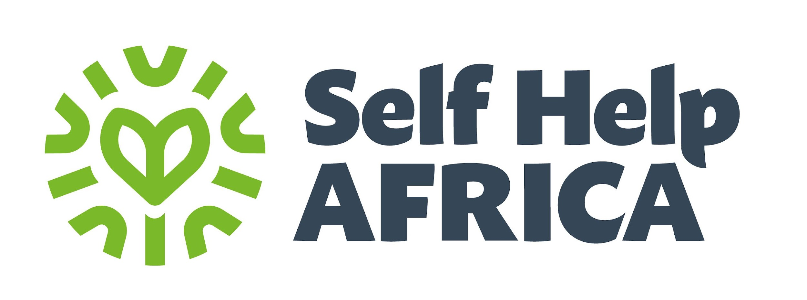

**JOB DESCRIPTION**

|  |  |
| --- | --- |
| **Job Title:** | Project Manager for FCDO |
| **Company:** | Self Help Africa |
| **Department:** | Programmes |
| **Location:** | Lilongwe |
| **Reports to:** | Livelihoods and Resilience Manager |
| **Salary:** | TBC |
| **Organisational overview** | **About Self Help Africa**  Established in 1984, Self Help Africa is an international development organisation that works through agriculture and agri-enterprise development to address hunger, poverty, social inequality and the impacts of climate change. We believe that equitable economic development is key to lifting communities out of long-term poverty, empowering them to take control of their futures and improving their quality of life.    In early 2023 we launched a new five-year organisation strategy, which defines shared mission as the alleviation of hunger, poverty, social inequality and the impact of climate change through community-led, market-based and enterprise- focused approaches, so that people can have access to nutritious food, clean water, decent employment and incomes, while sustaining natural resources.  Our wider organisation also includes social enterprise subsidiaries Partner Africa, which provides ethical auditing and consultancy services, and CUMO, Malawi’s largest micro-finance provider.  Our three core values are:  ▪ Impact: We are accountable, ambitious and committed to systemic change.  ▪ Innovation: We are agile, creative and enterprising in an ever-changing  World.  ▪ Community: We are inclusive, honest and have integrity in our relationships. |
| **Job Purpose:** | The position will lead and oversee the implementation of FCDO Humanitarian Project. The incumbent will lead and coordinate the project activities in liaison with all project consortium members leading different facets of the project. The Project Manager will be responsible for planning, executing, coordinating teams, manage resources and communicate with stakeholders to achieve quality standards of the project. The duties will include setting project milestones, monitoring progress and risks, facilitating communication between stakeholders, and ensuring that all deliverables meet the required standards. |
| **Key Responsibilities:** | * Overall management responsibility for effective and efficient management and delivery of the FCDO project and ensures the project is delivered to a high quality within budget and using adaptive management approach to meet deliverables and indicators in the logframe. * Define project scope, create and manage timelines, develop and maintain budgets, and ensure projects are completed on time and within budget. * Provide technical input for the implementation of the programme including in the preparation of work plans, strategies, training materials, guidelines and standard operating procedures and partner support. * Build and motivate project team, delegate tasks effectively, manage conflicts, and provide coaching and support to his or her team * Develop and maintain strong relationships within and outside SHA including with the Government of Malawi ministries and its departments and various private sector partners relevant to key components of the project. * Effectively communicate project progress, manage expectations, and build strong relationships with stakeholders, including clients, team members, and other relevant parties * Should be able to adjust project plans and strategies in response to changing circumstances, demonstrate resilience in the face of setbacks, and maintain a positive and proactive approach. * Coordinate partner and district level quarterly planning and review meetings for the project * Ensure that the project adopts best practices and core humanitarian standards in distribution, delivery, and coordination to ensure that lessons learned within the programmes are properly recorded and shared with consortium and other partners. * Assess the staff for technical training and capacity building needs and carry out in-house training, as well as arranging external training where required. * Ensure compliance to project agreement requirements in planning, financial management, procurement, monitoring and reporting, and facilitate further training where necessary. * Ensure accurate and timely reporting of programme finances and progress status; review actual financial performance against the budget; and explain variances on a regular basis. This will include strong foresight of the need for any re-budgeting and contract amendments in line with an adaptive management approach * Ensure the programme has sufficient systems in place to meet programme management standards and comply with donor regulations and good practice. * Oversee the programme’s compliance with monitoring and evaluation requirements, using data analysis as the basis for measuring performance. Ensure that knowledge management is central to the work plan. * Provide regular reporting to the Programmes Manager as per reporting guidelines including preparation and consolidation of monthly, quarterly and annual projects reports * Efficient resource management, including time, budget, and personnel, etc. * Facilitate a working environment of mutual trust, respect, and care among all staff. * Ensure safeguarding policy is adhered to by partners and staff and safeguarding is actively communicated and all stakeholders trained. Be an advocate for do no harm principles and the values of SHA * Ensure effective representation of SHA in different forums, meetings, networks and events. * Perform any other duties assigned by the supervisor |
| **Key Relationships:** | **Internal**   * The Deputy Country Director-Programmes, Agriculture and Livelihoods Programme Manager, National M&E Manager, Secretariat Coordinator, Project Accountant, Gender Advisors, SD, CD and others within. * Self Help Africa Malawi Country Programme and Administrative Staff   **External**   * All Consortium Members, Malawi Govt Ministries and all District councils concerned and Local civil society organizations (CSOs). |
| **Knowledge and Experience:** | * A high level of understanding of project cycle management approaches, project appraisal, monitoring and evaluation and partners’ capacity building. * Considerable experience in budgeting/financial procedures and writing management and financial reports to donors. * Proven experience in managing and collaborating with local and international downstream partners/ sub-awardees * Proven ability to motivate, provide technical support and guidance to a diverse team of staff and partners. * Good knowledge and understanding of key aspects of development work; including crisis modifier, disaster risk reduction (DRR) and preparedness, and cross-cutting themes (e.g. gender, environment, HIV/AIDS), and integration of climate change response in development programming. * Demonstrable experience in MEAL and motivation for learning and dissemination. * Skills in training/facilitation of development processes, including organisation and mobilisation of communities and networking among different development partners such as community-based organisations, government officers and SHA staff. * Commitment to international and humanitarian NGO codes, standards and practices. * High level of integrity and high standards of personal conduct and demonstrable skills in safeguarding and fraud prevention. * Track record of understanding and applying robust safeguarding mitigation measures and complying with a robust safeguarding policy |
| **Qualifications/Other Requirements:** | * Minimum of bachelor’s degree in humanitarian and emergency management, Agriculture, Nutrition, Community Development, Development Studies, or related discipline * Minimum 5 years’ experience in managing emergency response projects with experience in multi-purpose cash transfers, nutrition and crisis modifier. * Experience with EU funding * Skills in training/facilitation of development processes, including organisation and mobilisation of communities and networking among different development partners such as community-based organisations, government officers and SHA staff. * Understand climate change related issues and how they impact on the smallholder farmer, food and production and the nation at large. * Experience of working with mobile money operators and private sector players in the country * Have experience working with local CSOs * A mature self-starter, able to work independently, think critically and reflect and willing to take calculated risks to enable learning. * Good communication skills, excellent people management and interpersonal skills preferably in an NGO. * Strong skills in speaking and writing English with solid computer skills in Microsoft Word, Excel, PowerPoint and email, * Proven ability to motivate, provide technical support and guidance to a diverse team of staff and partners with minimum direct supervision. * Proven leadership and interpersonal skills and ability to build and motivate diverse and talented teams * Proficiency in Microsoft Office suite, including Word, Excel and Outlook required * Strong leadership skills, including strategic thinking, problem solving, effective communication and negotiating skills * Excellent interpersonal and supervisory skills |
| **Role Competencies:** | * Excellent communication skills. * Ability to work as part of a team across different cultures. * Ability to work with minimum supervision and take initiative. * Ability to solve problems and take corrective action. |

Self Help Africa takes the safety and well-being of all those we work with, and our staff, very seriously. We have a zero-tolerance policy on abuse. Our recruitment is safe, meaning that we recruit staff with the highest values and standards of ethical behaviour. Self Help Africa has a Safeguarding Children and Vulnerable Adults Policy, which reflects our commitment to protecting the people with whom we work. All candidates will be expected to comply with this policy and its procedures.

**For more information about the organisation, please visit our website at** [**www.selfhelpafrica.net**](http://www.selfhelpafrica.net/)**.**

*All candidates offered a job with Self Help Africa will be expected to sign our Safeguarding Policies and Code of Conduct as an appendix to their contract of employment and agree to conduct themselves in accordance with the provisions of these documents. Specific roles may require Police/DBS/ [relevant police authority] vetting.*

**This Job Description has been read and clearly understood.**

***___________________________ ___________________________ ______________***

***Employee Name Employee Signature Date***

***___________________________ ___________________________ ______________***

***Supervisor Name Supervisor Signature Date***

**Self Help Africa strives to be an equal opportunities employer**