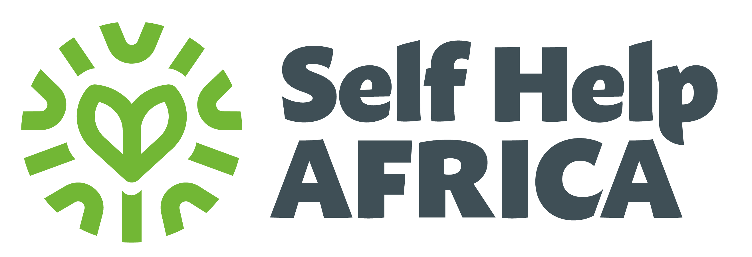
TERMS OF REFERENCE FOR SOURCING A TRAINER TO OFFER LIVESTOCK MANAGEMENT TRAINING FOR COMMUNITY ANIMAL HEALTH WORKERS (CAHWs) FOR BUILD NAPAK PROJECT

Introduction
Self Help Africa (SHA) is an international development organization dedicated to the vision of ‘Sustainable livelihoods and healthy lives for all in a changing climate’, with almost 50 years of experience working with smallholder farmers and their communities in Sub-Saharan Africa. In Uganda, SHA has over 20 years’ experience delivering enterprising solutions that help rural communities improve their food and nutrition security while improving their livelihoods and resilience.

SHA received funding from The Community Foundation of Ireland to support 1,000 smallholder farmers in Napak District for a period of 3 years (2023-2025). The project focuses on increasing climate smart agriculture production, improved marketing, financial inclusion and enterprise skills and improving household nutrition and WASH practices.

The BUILD project is located within the green belt of Karamoja where both livestock rearing and crop production are practiced, with livestock rearing being the pre-dominant activity. Much as they rear both small ruminants, poultry and cattle, cattle are the most highly valued livestock of all and yet the lack of veterinary services had led to high mortality rate of the cattle. It is based on this that the BUILD Project is working closely with the Community Animal Health Workers to offer better livestock management services to the supported community.

Objective of the TOR
To engage the services of a qualified trainer to deliver basic livestock management knowledge and skills to 24 Community Animal Health Workers in Poron and Apeitolim Sub-counties.

Scope of Work
The trainer will conduct a skills assessment through a pre-test and tailor the training to address these gaps and thereafter administer a post-test to assess the level of knowledge absorption. The training will be conducted for 3 days per training location at sub-county level from 14th to 19th October 2024.

The training will focus on livestock management and poultry husbandry, with specific attention paid to
- The nutritional management and feed formulation,
- Vaccination protocols,
- Animal welfare practices,
- Disease investigation and prevention and management,
- Diagnosis and treatment, of sick animals
- Young stock management
- Costing of treatment rendered to livestock.

Expected Outputs
- A comprehensive training report including details of the content covered and pre-test / post test evaluation results
- Provision of simple record keeping templates to help CAHWs track animals they have treated
- Effective delivery of the training content in Ngakarimojong, ensuring that complex concepts are explained in a simplified manner

Period of the assignment
The actual training dates will be from 14th to 19th October 2024. The trainer will be expected to submit a detailed training report within 1 week after training to the Project Officer for review and approved by the Project Manager before payment is processed.

Responsibilities and qualifications of the trainer
The trainer will be responsible for ;
- Delivering hands-on, practical training using simple and accessible language
- Working under the supervision of the Project officer to ensure the training is aligned with the Project’s objectives
- Tailoring the training to meet the needs of smallholder farmers in Karamoja region

Qualifications and Skills:
- A Bachelor's degree in Veterinary Medicine(B.V.M.).
- At least 3 years of experience in training smallholder farmers, preferably in rural areas of Uganda, with a focus on Karamoja.
- Fluency in Ngakarimojong is essential.
- Strong interpersonal skills and a proactive personality, with the ability to communicate and train effectively in rural contexts.

