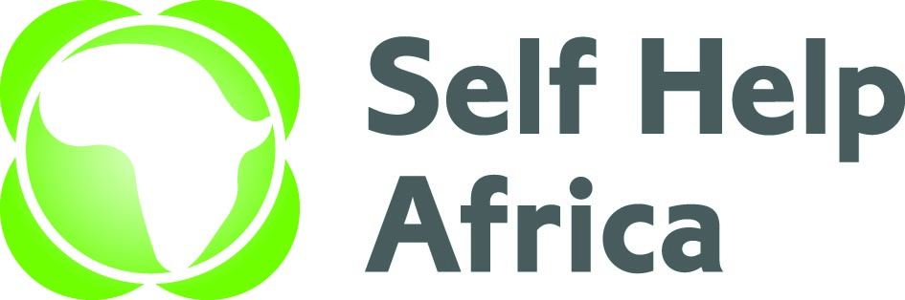

CONSULTANCY CALL
Self Help Africa (SHA) is an Irish based, International Non-Governmental Organisation (NGO) implementing rural development, sustainable livelihoods, and food security programmes in nine countries in Sub-Saharan Africa. In Uganda, SHA has been operational since 1989, implementing various programmes across all regions of the country.
Self Help Africa Uganda with funding from World Food Programme is implementing a 14 months’ project titled “Agriculture Market Support’’ in Adjumani and Kiryandongo districts. The project will support 12,670 smallholder farmers in Adjumani and Kiryandongo districts targeting refugees and host communities in Pakele, Itirikwa, Ofua, Ukusijoni and Ciforo sub-counties and Nyamahasa, Bweyale and Kigumba sub counties respectively. The project aims at a sustainable increase in food, nutrition and income security for smallholder farmers especially women and youths and increased employment opportunities for smallholder farmers. The project goal will be achieved through improved quality of targeted crops, PHM, and food safety, increased demand and supply of Agricultural services, increased pro-smallholder marketing among smallholders and strengthened national and sub national institutions for pro-smallholder policies and programmes.
CONSULTANT FOR TRAINING OF FARMER GROUPS ON NURSERY SEED PRODUCTION
Under the overall supervision of the Project Manager the Consultant will conduct a hands-on training and demonstration to farmers on tree seedling production and management.

• Specific objectives/scope of tasks for the consultant
- Equip participants with on-site knowledge and skills on good nursery set up and design, Key nursery operations, Pest and disease control, Record/inventory management, Cost benefit analysis and Marketing.
- Facilitate and enable establishment of 2 commercial tree nurseries at the identified suitable sites.
- Develop nursery user guide for farmers’ reference.
- Write and submit a complete report of the engagement.

The Terms of Reference for the assignment can be downloaded at https://selfhelpafrica.org/ie/category/tenders Qualified candidates should submit technical and financial proposals by E-mail as follows: -
procurement-uganda@selfhelpafrica.net
Please type “Consultant / Training of farmer groups on nursery seed production for the UGK 7” - [your consultant(s)/Consultancy firm name]” in the subject line of the e-mail.

The closing date for receiving the applications is no later than Close of Business on Friday 11th October 2024
Please do not send certificates at this stage. Due to the anticipated high volume of applications, kindly note that only shortlisted applications will be contacted.

Self Help Africa is an equal opportunities employer
Self Help Africa is completely against fraud, bribery and corruption. Self Help Africa does not ask for money for bids. If approached for money or other favors, or if you have any suspicions of attempted fraud, bribery or corruption please report this immediately by email to selfhelpafrica@expolink.co.uk. Please provide as much detail as possible with any reports.

