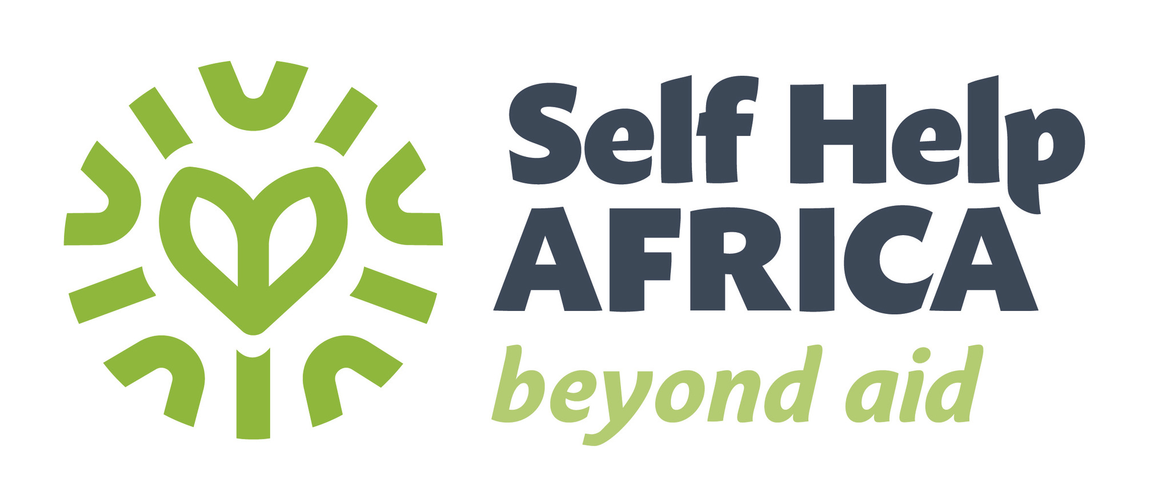

**VACANCY ANNOUNCEMENT**

Self Help Africa (SHA) is an International Non-Governmental Organization (NGO) dedicated to the Vision of an economically thriving and resilient rural Africa. We have over 50 years of experience working with small holder farmers , Farmer associations , Cooperatives and their livelihoods more sustainable and resilient to external shocks. SHA also builds awareness of issues affecting smallholders and represent their interests at policy and institutional level. SHA is a core member of the Gorta across Africa , Comprising of Self Help Africa , United Purpose, Partner Africa and TruTrade, The Gorta Group combines expertise in the Market based solutions to poverty and rural development , Climate change mitigation and resilience ; trade facilitation and farmer farmer and worker rights; underpinned by an inclusive ethos that specifically targets women and youth.

**Youth and Gender Officer (1 position) (Based in Adjumani)**

The Youth and Gender Officer will provide technical assistance for the application of a GYSI lens to further identify and address barriers to and gaps in optimal delivery and uptake of Agriculture and Market Support (AMS) Planning programming and services delivery across the two Districts of: Kiryandongo and Adjumani.

**Key areas of responsibilities include:**

* Strategy design, planning, monitoring, and implementation
* Networking, Learning, Policy Implementation
* Gender and social inclusion in project interventions
* Monitoring and Evaluation

**The Job Descriptions for the position is below**

Please visit our website at <https://selfhelpafrica.org/ie/category/careers/> to apply for the position.

**The closing date for receiving applications is not later than close of business Friday, 23rd February 2024.**

Please do not send certificates at this stage. Due to the anticipated high volume of applications, kindly note that only shortlisted candidates will be contacted.

**Self Help Africa is an equal opportunities employer**

Self Help Africa is completely against fraud, Bribery and Corruption . Self Help Africa does not ask for money for bids . if approached for money or other favour or if you have any suspicions of attempted fraud, Bribery or corruption , Please report this at selfhelpafrica.ethicspoint.com. Please provide as much detail as possible with any reports.

**JOB DESCRIPTION**

|  |  |
| --- | --- |
| **Job Title:** | Youth and Gender Officer |
| **Company:** | Self Help Africa |
| **Location:** | Adjumani |
| **Contract type:** | Fixed Term |
| **Reports to:** | **Project Manager** |
| **Organisation overview:** | **About Self Help Africa**  Self Help Africa is an international development organisation that works through agriculture and agri-enterprise development to end hunger and extreme poverty.    The organisation has Programmes in 15 countries in sub-Saharan Africa and implements projects in Brazil and Bangladesh.  In early 2023 we launched a new five-year organisation strategy, which defines  the shared mission as the alleviation of hunger, poverty, social inequality and the  impact of climate change through community-led, market-based and enterprise-  focused approaches, so that people can have access to nutritious food, clean  water, decent employment, and incomes, while sustaining natural resources.  Our wider organisation also includes social enterprise subsidiaries Partner Africa,  which provides ethical auditing and consultancy services, TruTrade, an innovative  trading platform in East Africa, and CUMO, Malawi’s largest micro-finance  provider.  Our three core values are:  ▪ Impact: We are accountable, ambitious and committed to systemic change.  ▪ Innovation: We are agile, creative, and enterprising in an ever-changing  world.  ▪ Community: We are inclusive, honest and have integrity in our  relationships. |
| **Job Purpose:** | S/he will provide technical assistance for the application of a GYSI lens to further identify and address barriers to and gaps in optimal delivery and uptake of Agriculture and Market Support (AMS) Planning programming and services delivery across the two Districts of: Kiryandongo and Adjumani. |
| **Key Responsibilities:** | **Responsibilities (R) and Activities** |
|  | **Strategy design, planning, monitoring, and implementation**   * Lead/support the development and implementation of evidence based, realistic and effective for gender equality, women empowerment, and youth engagement as directed by the technical leadership team under the Agriculture and Market Support (AMS). * Input into problem identification, causal and problem analysis and activity development. * Participate in Agriculture and Market Support (AMS) detailed implementation planning, and annual reviews, to ensure Gender and Youth responsive project planning processes are implemented throughout the life of the project. * Ensure that proper records are available to respond to the World Food Programme (WFP) result framework indicators in areas of women empowerment and gender equality, access to resources, leadership status within community, etc. * Provide technical leadership and technical support for the integration of Gender, Youth, and marginalized groups’ interests and concerns across the Agriculture and Market Support (AMS) Planning programming and service delivery. |
| **Networking, Learning, Policy Implementation**   * Establish all necessary relationships with WFP gender equality and youth empowerment partners within SHA and government stakeholders to ensure that gender and youth issues and priorities are tabled, addressed and lessons are shared. * Support formative research in the assigned operational districts. * Disseminates learning and ensures all staff at the field office level are updated on gender and youth priorities. * Support field level related experts/staff to measure the impact and document lessons learned and best practices. * Work closely with District Local Governments to improve GBV prevention and response services and develop technical and operation strategies for GYSI for sustainability. Document and disseminate knowledge management products including lessons learnt and best practices for the integration of GYSI in Agriculture and Market Support (AMS). * Prepare periodic technical reports for both internal and external clients. Perform other duties as may be assigned by and agreed upon with the supervisor. |
| **Gender and social inclusion in project interventions:**   * Ensure gender and social inclusion component in any type of project interventions; and * Manage data disaggregated by sex, age, and ethnicity from the records of project interventions. |
| **Monitoring and Evaluation:**   * Work the with Implementation Team (Training Field Officers) and MEL Associate to ensure gender sensitive data is regularly analysed and used to inform project implementation. * Support District MEL team to ensure that team members apply a gender analysis and youth perspective in the collection, analysis, and use of data. * Conduct regular field visits to ensure that program activities are gender sensitive, youth focussed and in line with the strategy. |
| **Key Relationships:** | **Internal:**   * Project Manager, Field Training Officers, Project Officers, & other project staff * Self Help Africa Uganda Country Programme Staff and administrative staff   **External:**   * Farmer Organizations, Farmer groups, youth and women groups, Local government, private sector actors, donors, Civil Society Organizations. |
| **Knowledge, Experience and Other Requirements** | **Education**   * A degree in Social Sciences, Development Studies Gender and/or Women’s Studies, Public Health, or a health-related field. * A Master of Public Health, Social Sciences, Development Studies, Gender and/or Women’s Studies, or a health-related field will be an added advantage.   **Experience:**   * 3-5 years of work experience on gender or social and behavioral change, conversant with adult learning and training of trainers’ methodologies, practical experience in women and youth programming • At least 3 years of work experience in gender analysis, training and mainstreaming. • Gender related work in an NGO setting. • Previous experience with livelihoods programs and or food assistance interventions.   **Desirable:**   * Strong interpersonal and communication skills and the ability to work effectively with a wide range of constituencies. • Excellent command of both oral and written English. * Effective interpersonal skills, maturity, intuitive, tact and a high sense of responsibility. * Analytical, training/facilitation skills. * Sensitivity to different aspects of diversity (cultural, religious, disability), firm belief in teamwork and sensitivity to HIV/AIDS. * The candidate should be a self-starter and a good team player. |

*All candidates offered a job with Self Help Africa will be expected to sign our Safeguarding Policies and Code of Conduct as an appendix to their contract of employment and agree to conduct themselves in accordance with the provisions of these documents. Specific roles may require Police/DBS/ [relevant police authority] vetting.*

**Self Help Africa strives to be an equal opportunities employer.**