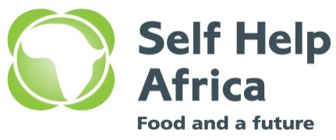 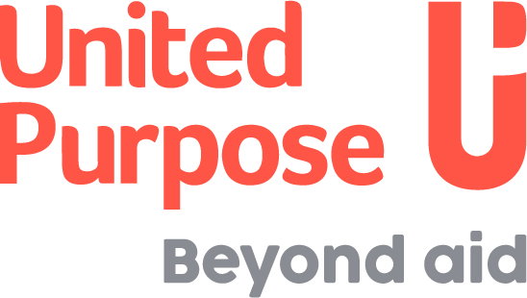

**JOIN OUR TEAM**

**ADVERT FOR WASH CIVIL TECHNICIAN**

**Background**

In August 2021, United Purpose and Self-Help Africa (UP/SHA) merged at a Global Level. In Malawi the country programmes have merged together under one organogram. The merger of United Purpose and Self-Help Africa has given us a unique opportunity to create an organisation built on our shared values and ideals and one that draws on our collective experience, knowledge and skills to expand and improve our work across the countries we work in. This is never more evident than in Malawi as it is also the only country where both UP and SHA operate.

UP/SHA Malawi is seeking to recruit a talented and dynamic Civils Technician for our Livelihoods Fund funded programme being implemented in Zomba and Machinga districts. Since January 2022, UP has been implementing Livelihoods Project in close collaboration with relevant Government line ministries. The Livelihoods Fund Project has a WASH component which aims to to reduce morbidity and mortality of rural people through rehabilitation of non-functional boreholes in Zomba and Machinga. The position is tenable in Machinga district

**Job Title: Civil Technician to be based in Machinga**

**Job purpose:**

To construct community WASH facilities in line with GoM standards. S/he will be reporting to the WASH Officer for day-to-day activities and to the Project Engineer for technical guidance.

**Key duties and responsibilities:**

* Repair/rehabilitation of broken-down boreholes, civil works construction and Afridev pump installation.
* Making sure that proper construction standards are maintained.
* Keeping accurate records of construction activities and assisting in preparing progress reports.
* Mapping of all WASH facilities using mWater platform
* Ensure implementation of project activities in line with UP’s safeguarding policy and procedures. This includes ensuring promotion of feedback channels to project participants and reporting concerns and feedback.
* Keeping appropriate records of and arranging for the maintenance /service of field equipment.
* Assisting in other water and sanitation program activities as requested by the Engineer.

**Minimum Requirements:**

* Grade 1 in brick laying and minimum of MSCE qualification
* JCE with 3 years’ practical experience in implementing Charity Water Grant will be considered in lieu of MSCE.
* At least three years’ practical field experience in borehole construction/rehabilitation and hand pump and submersible pump installation and construction of gravity fed systems.
* Good understanding of participatory demand driven and community-based management to rural water supply and sanitation

**Desirable:**

* Skills on ICT operation, and proficient in using MS Office
* Excellent interpersonal skills
* Respect to cultural diversity and gender sensitivity
* Ability to work under pressure, solve problems and take corrective action.
* Ability to work in a rural community on implementing programmes.
* Excellent interpersonal and communication skills and analytical/problem-solving abilities.
* High levels of integrity, honesty, strong ethics but also a quick learner

**How to apply**

Qualified and interested candidates who meet the stated requirements must submit a completed Application Form. Please visit <https://gsha.box.com/v/applicationform> to download the Application Form, and then submit the completed form via email only to [applicationsmw@united-purpose.org](mailto:applicationsmw@united-purpose.org)

When submitting, please cite the position you are applying for in the subject title and the following should be included; **Cover letter, CV, Copies Certificates and SHA/UP Application form** saved in your name. Any applications that do not include these will not be considered.

No hard copies / physical applications will be accepted. **Please note zipped Folder will not be accessed.**

**Closing date for the receipt of completed application forms is 12:00 Midnight of 31st July, 2023** Only short-listed candidates will be contacted.

United Purpose/Self Help Africa takes the safety and well-being of all those we work with, and our staff, very seriously. We have a zero-tolerance policy on abuse. Our recruitment is safe, meaning that we recruit staff with the highest values and standards of ethical behaviour. United Purpose has a Safeguarding Children and Vulnerable Adults Policy, which reflects our commitment to protecting the people with whom we work. All candidates will be expected to comply with this policy and its procedures.

For more information about the organisation, please visit our website at [www.united-purpose.org/malawi/](http://www.united-purpose.org/malawi/)

**UP /SHA is an equal opportunity employer.**