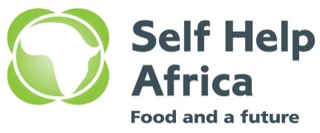 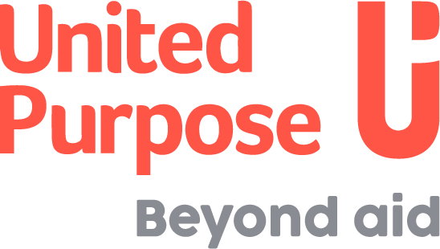

**JOIN OUR TEAM**

**ADVERT FOR THE MONITORING EVALUATION AND LEARNING COORDINATOR - CHITIPA**

**Background**

In August 2021, United Purpose and Self-Help Africa (UP/SHA) merged at a Global Level. In Malawi the country programmes have merged together under one organogram. The merger of United Purpose and Self-Help Africa has given us a unique opportunity to create an organisation built on our shared values and ideals and one that draws on our collective experience, knowledge and skills to expand and improve our work across the countries we work in. This is never more evident than in Malawi as it is also the only country where both UP and SHA operate.

Global Evergreen Alliance has formed a consortium to implement the Restore Africa Project: Catholic Relief Service, the lead agency, and Self Help Africa-United Purpose, World Vision International, CARE, Total Land Care, OSSEDI, ICRAF and Blantyre Diocese Cadecom are the implementing organizations.

The project will improve livelihoods, food security and resilience to climate change in Malawi through restoring ecosystem services and improved management of agricultural, pastoral and forest areas contributing to emissions reductions. This programme will enable and build substantial carbon sinks and sequestration opportunities, allowing viable returns to both farmers and investors.

The project will build capacity of national and local-level decision-makers in landscape restoration through ecosystem-based strategies. Strengthening local capacity and fostering cross-learning for improved management of land and forest areas through adoption and scale up evergreening practices. It will strengthen landscape, forest, and watershed management activities to increase tree biomass and carbon, crop and livestock productivity, environmental resilience of landscapes, support climate-resilient value-chains and market linkages (including carbon markets). The project will carry out multi-platform behavior change communications campaigns tailored to different audiences to address barriers to uptake of ecosystem-based strategies and will implement monitoring systems to track successes of ecosystem-based activities, tree growth and land cover, land restoration and biomass accumulation.

**Job purpose:**  MEAL Coordinator will be responsible for all data collection, management, analysis, and learning activities in order to ensure effectiveness, efficiency and accountability in implementation of the Self Help Africa/United Purpose project activities. S/he will work closely with the Project Manager, Project Coordinator and Field Facilitators to assess field conditions, support capacity building initiatives, and facilitate the collection of quality data.

**Key duties and responsibilities**

* Conduct regular visits to project sites to carry out process monitoring as well as gather feedback from the beneficiary community about progress of implementation of the project.
* Support with supervising external consultants conducting evaluation studies (baseline, mid-term, and end-line surveys)
* Organize and coordinate knowledge sharing and best practices dissemination workshops at district level.
* Support the Project Manager in preparation of high quality monthly, quarterly and annual reports for submission
* Lead/ Support the development and implementation of a Project Results Based Management System to ensure that data and findings translate into learning that is embedded in the programme, leads to adaptations where necessary and contributes to institutional knowledge.
* Coordinate processes of collection/documentation of lessons learnt, best practices and success stories from districts and dissemination for policy and practices change at community and district levels.
* Lead/ Support the production of publications and other specific papers based on programmatic learning that can be shared within the wider community.
* Ensure that the highest standards of accountability through good communication and information sharing within and outside the districts and through active participation of staff, beneficiary and other stakeholder are applied to all stages of the project.
* Perform data quality assurance through data verification and audit processes
* In conjunction with the Project Manager, formulate and design capacity building framework, guidelines and tools for staff, partners and beneficiaries.
* Conduct training needs assessment of project teams, and project implementing partners, and develop appropriate training designs.

**Minimum Requirements**

* Minimum of a Bachelor’s Degree in Social Sciences, Agriculture Economics, Project Management, Monitoring & Evaluation, Statistics or other related fields. Possession of a Master’s Degree in the above areas is an added advantage.
* Must possess at least 3 years professional experience in Monitoring and Evaluation with practical experience in the use of modern data collection methods as well as facilitation of trainings for project staff in M&E.
* Practical Experience in setting up and managing a Monitoring & Evaluation, Accountability and Learning system while ensuring adequate technical capacity to enhance the system's performance to achieve optimal program reporting
* Knowledge and understanding of project monitoring and evaluation, including data management tools
* Knowledge of the current M&E trends and debates especially around M&E systems in development organisations
* Strong analytical and planning skills and an understanding of a range of methods for monitoring, evaluation and assessment to promote evidence-based learning.
* Demonstrated ability to design, commission, and manage assessments and evaluations.
* Experience in designing and coordinating surveys.

**Desirable**

* Good working knowledge of data analysis packages such as SPSS, STATA, Excel and mobile data collection applications.
* Good knowledge of Ms Office.
* Excellent interpersonal and communication skills and analytical/problem-solving abilities.

**How to apply**

Qualified and interested candidates who meet the stated requirements must submit a completed Application Form. Please visit <https://gsha.box.com/v/applicationform> to download the Application Form, and then submit the completed form via email only to [applicationsmw@united-purpose.org](mailto:applicationsmw@united-purpose.org)

When submitting, please cite the position you are applying for in the subject title and the following should be included; **Cover letter, CV, Copies Certificates and SHA/UP Application form** saved in your name. Any applications that do not include these will not be considered.

No hard copies / physical applications will be accepted. **Please note zipped Folder will not be accessed.**

**Closing date for the receipt of completed application forms is 12:00 Midnight of 16th June 2023** Only short-listed candidates will be contacted.

United Purpose/Self Help Africa takes the safety and well-being of all those we work with, and our staff, very seriously. We have a zero-tolerance policy on abuse. Our recruitment is safe, meaning that we recruit staff with the highest values and standards of ethical behaviour. United Purpose/Self Help Africa has a Safeguarding Children and Vulnerable Adults Policy, which reflects our commitment to protecting the people with whom we work. All candidates will be expected to comply with this policy and its procedures.

For more information about the organisation, please visit our website at [www.united-purpose.org/malawi/](http://www.united-purpose.org/malawi/) www.selfhelpafrica.org/ie/malawi/

**UP /SHA is an equal opportunity employer.**