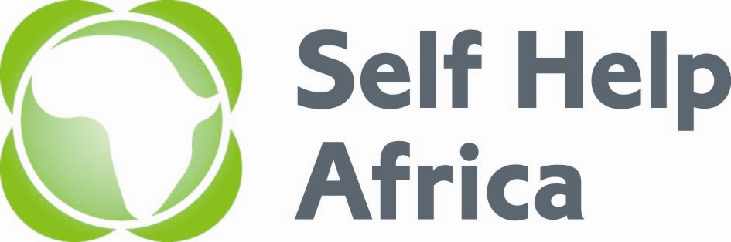
JOB DESCRIPTION

Job Title: | Finance & Administration Intern
Company: | Self Help Africa – Kenya
Location: | Nairobi, Kenya
Reports to: | Finance Officer
Job Advert: | Apply between 4th April to 13th April 2023
Job Purpose: | The purpose of this exercise is to provide an opportunity to the student to apply skills acquired through a real work situation, expose the student to business functions which are not available to her/him at the university and build confidence in real work situation, problem solving, teamwork and working with professionals in the world of work.
Key Responsibilities: | For Finance:  1. Updating of voucher and journal files to ensure all support documents are attached.  2. Ensure all payment support documents have been stamped paid  3. Help in follow up of receipts from vendors and liaises with Admin & Logistics Officer on the missing receipts  4. Help in arranging and re arranging archived files and ensuring documents are secured properly to avoid loss of trail.  5. Scanning of all support documents for Salesforce - procurement process  6. Assist in photocopying any relevant documents.  7. Update the cheque dispatch book.  8.Scanning of intercompany Documents.  9. Matching of the requests, CBAs, Orders &Invoices.  10.Initiating payment vouchers.  11.Maintaining little cab ((taxi) file - daily trip Invoices and reconciliations.  12.Fuel reconciliations  13.Suppliers statements reconciliation.  14. Assist in drawing the LPOs.  15 Assit in audit for retrieval of documents.  16. Assit in Audit Preparation-(documentation).  17.Assit in making Mpesa payments -validation.  18. Assit in Filing of Witholding Tax returns.  19. Assit in Naivas Card Reconciliation.  For Admin:  1. Filing  2. Physical Asset and inventory checks  3. Front office management and handling of the switchboard and direct phone calls to the respective team members  4. To help in securing quotations as and when required  5. Provide monthly reports as required.  6.Issuance of Inventory to Staff.  7.Assist in Asset Disposal.  8. Assit in updating the asset register.
Person Specification: | - Must have successfully completed their undergraduate degree in finance, business administration or a related field in the last two years.  - Must not have worked in a paid position before.  - This must be the first internship.  - CID Certificate of good behaviour or application in progress  - Two references from faculty, professional contacts, or community.

Key Relationships: | Key relationships:  Internal  - Head of Finance and Administration  - Project Accountants  - Administration & Logistics Officer
Duration of contract | Three months, with a possibility of extension

For the full Job Description and information on how to apply, visit https://selfhelpafrica.org/ie/category/careers-kenya/

The closing date for receiving applications is not later than 5.00pm EAT on Thursday 13th April 2023.

Please do not send certificates at this stage.
Due to the anticipated high volume of applications, kindly note that only short-listed candidates will be contacted.

Self Help Africa is an equal opportunity employer

