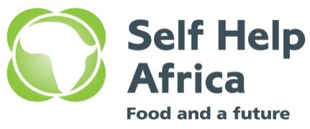 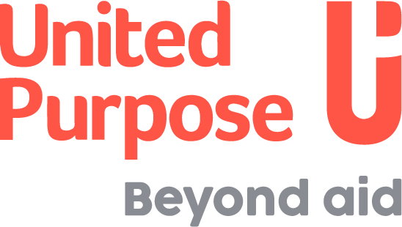

**JOIN OUR TEAM**

**ADVERT FOR DIWASH PROJECT MANAGER TO BE BASED IN MPONELA**

**Background**

In August 2021, United Purpose and Self-Help Africa (UP/SHA) merged at a Global Level. In Malawi the country programmes have merged together under one organogram. The merger of United Purpose and Self-Help Africa has given us a unique opportunity to create an organisation built on our shared values and ideals and one that draws on our collective experience, knowledge and skills to expand and improve our work across the countries we work in. This is never more evident than in Malawi as it is also the only country where both UP and SHA operate.

UP/SHA Malawi is seeking to recruit a talented and dynamic team to start work 1st February 2023 for our Charity: Water funded WASH programme, called Dowa Integrated Water Supply, Sanitation and Hygiene (DI-WASH), and for our drilling team that works with that programme. Since January 2019, UP has been implementing the first four phases of DI-WASH in Dowa District primarily targeting underserved communities in five TA’s in close collaboration with relevant Government line ministries’ and WASH actors. UP/SHA will be implementing phase 5 of the DI-WASH Program effective 1st January 2023.

The goal of the program is to reduce morbidity and mortality of rural people of Dowa, especially under five children caused by WASH related diseases. The objective is to increase access to safe water and improved sanitation and hygiene practices in target communities and selected schools and ensure sustainable operation and maintenance of WASH facilities by beneficiaries in partnership with the district councils and private sector.

**Job Purpose:** Reporting to the Deputy Program Manager (DPM), s/he is accountable for the overall planning, implementation, monitoring, quality - control and reporting of all WASH Projects. S/he will manage human, financial and other resources for all the WASH Projects. S/he will have responsibility for ensuring that the projects are managed effectively and efficiently. S/he will line manage all WASH Project Teams in Mponela, working in close collaboration with Project Accountants.

**Key duties and responsibilities**

* Provide overall day to day management oversight for the planning and delivery of WASH projects in Dowa, ensuring that all projects are implemented within acceptable quality, timeframe and budget.
* Ensure the implementation of all WASH projects are in compliance with donor’s requirements, government policies and global and national standards.
* Provide technical leadership in WASH infrastructure, Community Based Management (CBM), Sanitation Marketing and Systems strengthening approaches
* Ensure effective project budgetary control and monitoring is in line with UP’s financial procedures and guidelines, and fraud and risk management policies.
* Produce timely and quality technical and financial reports both for donors and internal use; timely review & submit the reports to DPM for review.
* Ensure proper project/program assessments, design, monitoring, evaluation and knowledge management processes are employed in the WASH program; and fully engage to make sure that appropriate monitoring tools including electronic based platforms are used to support the monitoring and decision-making processes.
* Develop and submit weekly updates and monthly monitoring and documentation reports to Regional WASH Manager.
* Ensure that appropriate human resource performance monitoring mechanisms with proper coaching and mentoring are practiced to enhance smooth staff relations and accountability.
* Work with the Regional WASH Program Manager to handle WASH donors, support donors and partners’ visits, briefings and meetings
* Promote major cross cutting themes including environment, gender, protection, disability, peace building and core values of the organization
* Ensure implementation of project activities in line with UP’s safeguarding policy and procedures. This includes ensuring promotion of a positive culture of openness and transparent where team members are able to raise concerns.
* Support UP’s business drive to run its rig unit as a social enterprise that delivers sustainable, cost effective and quality services
* Represent UP at national sector technical forums, events and meetings, where agreed with Regional WASH Program Manager
* Ensure safeguarding issues are implemented and reported in all WASH projects

**Qualifications, skills and experience**

* At least BSc Degree in Engineering, Water Resources Management, Public Health, Environmental Health & Related Fields. An MSc degree in these areas will be an added advantage.
* At least 5 years relevant experience in WASH in an international NGO
* Strong character traits, ability to handle stress, cultural and gender sensitivity and integrity;
* Proven experience of managing donor(s) funded projects or programs;
* Good computer skills including MS Word, Excel and internet;
* Knowledge and Experience in WASH infrastructure, Community Based Management (CBM), Sanitation Marketing and Systems strengthening approaches
* Demonstrable understanding of safeguarding risks and mitigating actions.
* Experience in developing and implementing monitoring and evaluation systems including e-monitoring
* Experience in proposal development, budget preparation and report writing;
* A full clean driving licence and ability to drive a four-wheel drive manual vehicle is essential.

**Key Competencies/Attributes:**

* Excellent communication skills, both oral and written in English
* Creates and encourages a climate of team-work and collaboration in a diverse cultural environment.
* Consistently achieves high-level results, manages and delivers projects on-time and on-budget.
* Has high-level management and supervisory skills;
* Result oriented and provides others with a clear direction; motivates and empowers others

**How to apply**

Qualified and interested candidates who meet the stated requirements must submit a completed Application Form. Please visit <https://gsha.box.com/v/applicationform> to download the Application Form, and then submit the completed form via email only to [applicationsmw@united-purpose.org](mailto:applicationsmw@united-purpose.org)

When submitting, please cite the position you are applying for in the subject title and the following should be included; **Cover letter, CV, Copies Certificates and SHA/UP Application form** saved in your name. Any applications that do not include these will not be considered.

No hard copies / physical applications will be accepted. **Please note zipped Folder will not be accessed.**

**Closing date for the receipt of completed application forms is 12:00 Midnight of 21st April, 2023** Only short-listed candidates will be contacted.

United Purpose/Self Help Africa takes the safety and well-being of all those we work with, and our staff, very seriously. We have a zero-tolerance policy on abuse. Our recruitment is safe, meaning that we recruit staff with the highest values and standards of ethical behaviour. United Purpose has a Safeguarding Children and Vulnerable Adults Policy, which reflects our commitment to protecting the people with whom we work. All candidates will be expected to comply with this policy and its procedures.

For more information about the organisation, please visit our website at [www.united-purpose.org/malawi/](http://www.united-purpose.org/malawi/)

**UP /SHA is an equal opportunity employer.**