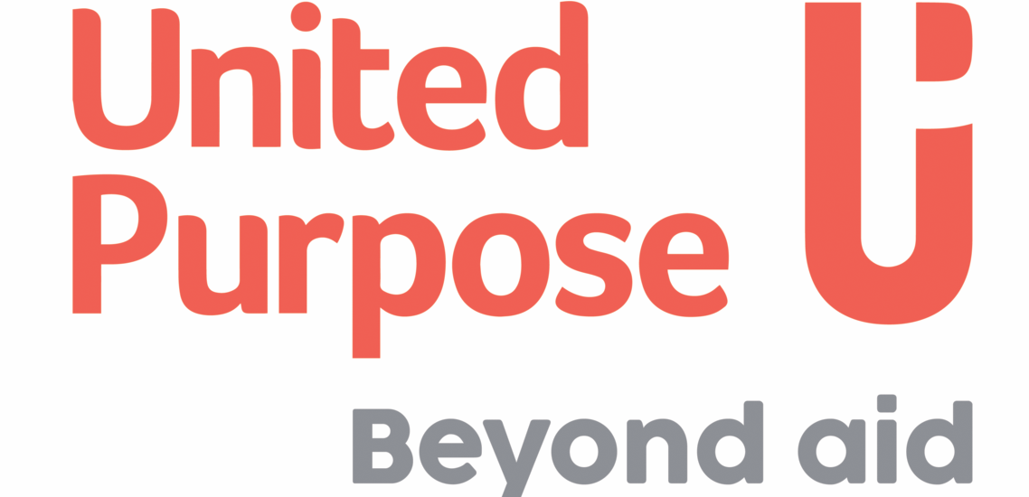

JOB DESCRIPTION
Job Title: | Agriculture and Natural Resource Management Officer
Company: | Self Help Africa / United Purpose
Location: | Kabale
Contract type: | Fixed Term
Hours: | 40
Reports to: | Project Manager
Organisation overview: | About Self Help Africa & United Purpose  In late 2021 Self Help Africa (SHA) and United Purpose (UP) merged. The two organizations – one headquartered in Ireland and the other in Wales – implement projects to end extreme hunger and poverty.  This merger doubled our size and reach – and means that in 2023 we are implementing poverty eradication projects in 17 countries, mainly in sub-Saharan Africa. Collectively, we are also part of a group that includes social enterprise subsidiaries Partner Africa, TruTrade and Cumo Microfinance.  In 2022 our work reached more than six million people and invested upwards of €45m in more than 100 development programs designed to improve food systems, facilitate access to markets and financial services, combat climate change, and gender inequality, and improve access to clean water, sanitation, and hygiene.  This is an exciting time to join us as we unite two like-minded and entrepreneurial organizations seeking to tackle global challenges in progressive and innovative ways.
Job Purpose: | As Agriculture and Natural Resource Management Officer under the supervision of the Project Manager, you will be required to facilitate processes promoting sustainable use and development of land resources for variety of purposes which may include organic agriculture, reforestation, water resource management and eco-tourism projects in Kigezi Region. The purpose of the job is to plan, facilitate and support smallholder farmers dependent on natural resources to address their environmental vulnerabilities to achieve sustainable livelihoods and land restoration for improved agriculture output. This role demands direct engagement with communities and other stakeholders including the Local Government within the project area. This also includes technical backstopping and other support to beneficiary individuals, producer organisations and associations and other stakeholders like local CBOs/NGOs, Local Government and private sector players, who are working within the project area
Key Responsibilities | Responsibilities (R) and Activities | Results
 | R1: Facilitate planning process and implementation of activity plans with project beneficiaries/ participants  - Develop detailed work plan on related to the key project activities  - Providing sensitization on laws, policies and guidelines that relate to sustainable land management to variety of purposes which may include organic agriculture, reforestation, water resource management and eco-tourism projects in Kigezi Region  - Support identification of strategic locations for specific interventions (e.g. areas for afforestation, reforestation and agroforestry, terraced farming and rainwater harvesting practices and establishment of vegetative barriers and other soil and water conservation methods) for soil stabilization and control.  - Provide technical expertise and strategic guidance to all NRM components of the project assuming quality control of interventions and support the Project Manager in the coordination and implementation of planned activities as stipulated in the project document/work plan .  - Prepare reports on group and/or community planning processes, activity implementation and project progress in accordance with the implementation plan. | - Project activity plans approved and implemented as agreed.  - Community members understand project objectives, and processes, and deliverables  - Roles and responsibilities of different actors are understood by all  - High quality and timely implementation of activities.  - Progress on project implementation is well monitored and documented.  - Clear, timely and quality reports are shared
 | R2: Liaison and linkage with government officials, local businesses, CBOs and other service providers within the project area.  - Promote linkages and cordial relationships with government officials and other NGOs  - Identify public and private sector service providers within the project area whose services and activities may be useful to the project beneficiaries.  - Ensure technical support is provided in the implementation of CSA and SLM aspects of integrated land management plans in conjunction with other technical officers  - Coordinate with local communities, local government, and other projects in the identification and implementation of sustainable land management solutions in environmentally fragile landscapes  - Support the PM in creating awareness on project activities and approach to government officials, businesses and NGOs in the project area.  - Perform any other assignment that may be given to you regarding linkages and liaison with other NGOs, private and the government sectors. | - Effective linkages with local government officials, CBOs/NGOs, and private sector  - Information on public and private sector services providers available to smallholder farmers  - Local government officials and businesses understand project objectives and processes  - Well-coordinated effort to ensure the local government and private sector provide technical oversight and other services to the farmers.
 | R3: Supporting institutional and business development for smallholder farmers and/or farmer groups  - Support groups formation and organisational development processes, including registration and development of constitutions and/or group rules/regulations  - Prepare and conduct producer/ farmer organization and association profiling and capacity assessment to identify needs including training and other capacity needs.  - Participate in the assessment of the farmers’ training needs, review of existing materials, and design of training manual for CSA and SLM, including core SHA approaches and Functional Land Scape Approaches.  - Support the effective roll-out of CSA and SLM training to smallholder farmers including field demonstrations.  - Link farmers to market players including input providers, post-harvest equipment, suppliers, financial institutions, market information providers, and buyers.  - Oversee the implementation of eco-businesses (including ecotourism and waste management)  - Contribute to the planning and carrying out of exchange visits, conferences, and farmer exhibitions on product marketing. | - Organised producer groups and other business associations  - Up-to-date information on agricultural opportunities by smallholder farmers and community members  - CSA/SLM training manual tailored to farmers’ needs  - Farmers capacity built on CSA and SLM practices.  - Market information services available for smallholder farmers.  - Increased skills and knowledge of smallholder farmers.  - Improved green economy businesses for women and youth
 | R4: Monitoring, Evaluation, Accountability and Learning (MEAL)  - Coordinate monitoring / follow up of NRM activities with project staff, partners and government officers. Facilitate learning, promote peer-to-peer learning between staff and partners, participate in relevant national networks, and actively engage in organization-level focal groups.  - Explore opportunities for positioning, innovation, upscaling and potential follow up projects | - Effective monitoring, reflection and evaluation system  - Project reporting contribute to sector learning and SHA track-record externally.
Qualifications/Other Requirements: | - A Bachelors Degree in Land Management, Agriculture, Agribusiness, Agriculture Extension or related disciplines  - Knowledge and experience in Natural Resource Management, Land Restoration, and Soil Sciences will an added advantage  - Experience in participatory market system programming and value chain analysis/Development of different agricultural commodities  - Understanding of key aspects of SHA development work; including food, nutrition, gender and livelihood security and other cross-cutting themes (e.g. youth, social inclusion, environment, HIV and AIDS);  - Skills in training and facilitation of community processes, including organization and mobilization of communities and networking among different development partners such as youth groups, community-based organisations, government officers and SHA staff;  - Ability to effectively use MS Office suite;  - High level of integrity and high standards of personal conduct;  Desirable  - Experience working in project geographical region  - Experience working with farmer groups and private sector actors..
Key relationships: | Internal  - Project Manager, Project Officers, technical Coordinators & other project staff  - Self Help Africa Uganda Country Programme Staff and administrative staff  External  - Farmer groups, youth and women groups, government departments, private enterprises, donors, Civil society organisations
Most Critical Proficiencies: | - Excellent communication skills  - Ability to work as part of team across different cultures.  - Ability to work with minimum supervision and take initiative  - Ability to solve problems and take corrective action.

All candidates offered a job with Self Help Africa/United Purpose will be expected to sign our Safeguarding Policies and Code of Conduct as an appendix to their contract of employment and agree to conduct themselves in accordance with the provisions of these documents. Specific roles may require Police/DBS/ [relevant police authority] vetting.

Self Help Africa/United Purpose strive to be an equal opportunities employer.

