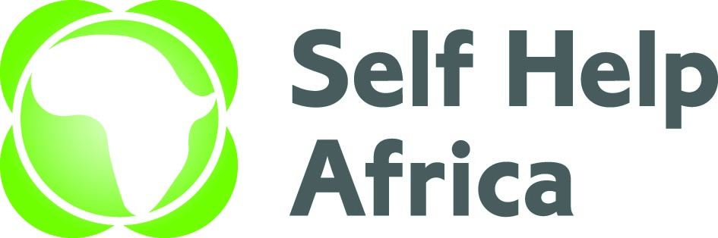

CONSULTANCY CALL FOR BASELINE SURVEY

Self Help Africa (SHA) is an international NGO dedicated to the vision of an economically thriving and resilient rural Africa. We have 50 years of experience working with smallholder farmers, farmer associations, cooperatives and agribusinesses across Africa to help farmers grow and sell more food, improve diets, diversify incomes and make their livelihoods more sustainable and resilient to external shocks. SHA also builds awareness of issues affecting smallholders and represent their interests at policy and institutional level.
Self Help Africa Uganda received funding from Community Foundation in Ireland (CFI) to implement a 3-year project in Napak District aiming at building livelihood and resilience of 1,000 smallholder farmers clustered in to 40 farmers’ groups in Poron and Apeitolim sub-counties. The BUILD programme falls under SDG Goal 1: No Poverty and Goal 2: Zero Hunger with an overall aim of strengthening resilience of smallholder farmers, women, and youth through improved food security and climate adaptation for sustainable development in Napak district, Karamoja Sub region to be achieved through improved climate smart agriculture production, improved marketing, financial inclusion and enterprise skills for smallholder farmers, and promote household nutrition and WASH practices.
Self Help Africa Uganda urgently seeks to recruit a suitable Consultant to undertake the following task.

CONSULTANT TO CONDUCT A BASELINE SURVEY FOR BUILD PROJECT IN NAPAK DISTRICT

Under the overall supervision of the Regional Programme Manager and the Head of Programmes, the Consultant will provide an analysis of the current situation, identify the project starting points, set benchmarks against which progress can be assessed or comparisons made as well as providing a deep contextual understanding of community vulnerabilities; household food security; access to financial services; knowledge and practice of climate smart agricultural technologies, nutrition patterns and WASH-related needs in the project area and mapping stakeholders of the different actors working in the relevant spheres of the project. Key areas of responsibilities include:
- Develop data collection tools that will be reviewed by the SHA MEL Advisor at the start of the survey
- Write an inception report with detailed study tools
- Present, to the relevant stakeholders, the preliminary findings during the validation workshop
- Write a final report (1 CD with the report, electronic copy and 4 hard copies).
The Terms of Reference for the assignment can be downloaded at https://selfhelpafrica.org/ie/category/tenders Qualified candidates should submit technical and financial proposals by E-mail as follows: - uganda@selfhelpafrica.net Please type “Consultant / Baseline Survey for BUILD-Napak Project” - [your consultant(s)/Consultancy firm name]” in the subject line of the e-mail.

The closing date for receiving the applications is no later than Close of Business on Sunday 26th March, 2023
Please do not send certificates at this stage. Due to the anticipated high volume of applications, kindly note that only shortlisted applications will be contacted.

Self Help Africa is an equal opportunities employer

Self Help Africa is completely against fraud, bribery and corruption. Self Help Africa does not ask for money for bids. If approached for money or other favors, or if you have any suspicions of attempted fraud, bribery or corruption please report this immediately by email to selfhelpafrica@expolink.co.uk. Please provide as much detail as possible with any reports.

