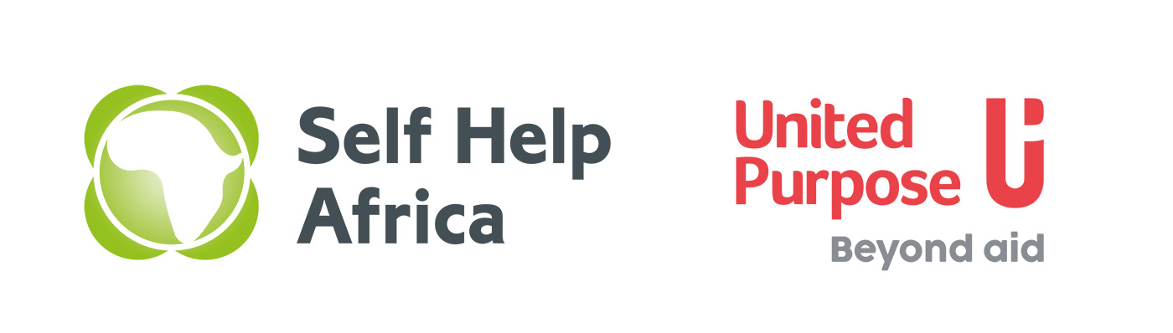

**Vacancy**

**Marketing Officer**

**Commercialisation of the Chitetezo Mbaula**

**Job Description and Specification**

**Background**

In August 2021, United Purpose and Self-Help Africa merged at a Global Level. In Malawi the country programmes have merged together under one organogram. The merger of United Purpose and Self-Help Africa has given us a unique opportunity to create an organisation built on our shared values and ideals and one that draws on our collective experience, knowledge and skills to expand and improve our work across the countries we work in. This is never more evident than in Malawi as it is also the only country where both UP and SHA operate.

**The role**

With funding from Energising Development (EnDev), United Purpose is implementing a project to strengthen the cleaner cookstove market, by supporting to the distribution, marketing and sales of the Chitetezo Mbaula across 5 districts in Southern Malawi.

*Project Goal:*

The project’s overall goal is to contribute towards the NDC and SEfor4All Action Agenda targets of 3.5 million by 2025 and 5 million by 2030. The project works to support the commercial market, by strengthening the value chain, through the provision of distribution, marketing and sales support to the Chitetezo Mbaula market.

*The project provides:*

1. More convenient and diverse access to CM for customers;
2. More flexibility, opportunities and incentives for supply chain actors;
3. Continued market growth and awareness of CM;
4. Markets for viable alternative cleaner cooking solutions.

We are looking for a hard-working and dynamic **Marketing Officer** to join our team based in Blantyre.

**Job Identification**

Job Title: Marketing Officer

Location: Based in Blantyre – working regionally

Duration: 24th October - 28th February 2022 (With possibility of extension dependent on funding)

**Reporting Relationship**

Supervision received: Project Manager

Coordination: Close collaboration and liaison with fellow Marketing Officers and energy team members.

**Job Purpose**

The Marketing Officer has responsibility for sales, marketing and promotion activities, ensuring that targets are met and all issues are reported to management in a timely manner. They will also be responsible for planning and reporting.

**Key Duties and responsibilities**

* Design marketing materials, messaging and activities to improve Chitetezo Mbaula (CM) sales
* Contribute innovative ideas towards the long term sustainability of the CM value chain
* Build capacity of supply chain actors through trainings and business development support
* Oversee stove purchases and transportation including coordination with production groups, conducting quality control, managing payments and completing necessary forms and receipts
* Keep robust and detailed records of activities including stove sales tracking, contributing to donor reports, writing case studies and providing supporting documents for financial and audit purposes
* Source new opportunities for sales through partnering with private (e.g. corporates/retailers), public (e.g. government initiatives) and third sector (e.g. development projects)
* Maintain strong relationships with team members, supply chain actors and partners
* Uphold organisation’s safeguarding principles and follow safeguarding policies at all times
* Perform duties as requested by project manager

**Experience and Qualifications**

*Essential*

* Minimum of 2 years in a similar position
* Experience of marketing and promotion of products
* Diploma in Marketing, Business management, or Community Development
* Knowledge and understanding related to Chitetezo Mbaula
* Excellent communication and facilitation skills
* Strong analytical, problem solving and decision-making skills
* Fluency in written and spoken English and Chichewa
* Computer skills, particularly MS Office (word, excel, powerpoint)
* Full clean motorcycle licence

Desirable

* Experience with decentralised energy businesses
* Graphic design / video editing skills including examples of work

**HOW TO APPLY:**

Qualified and interested candidates who meet the stated requirements must submit a completed Application Form. Please note that CVs and cover letters will not be accepted.

Please visit <https://united-purpose.org/s/UP-Job-Application-Form-2wtb.doc> to download the Application Form, and then submit the completed form via email only to;

[applicationsmw@united-purpose.org](mailto:applicationsmw@united-purpose.org) When submitting, please cite the position you are applying for in the subject title. Any applications that do not include this in the title will not be considered. Please also ensure that the application and cover letter is saved as per the following example: [your name] _**Marketing Officer** application. No hard copies / physical applications will be accepted.

Closing date for the receipt of completed application forms is **12:00 Midnight of 11th September 2022.** Only short-listed candidates will be contacted.

United Purpose / SHA takes the safety and well-being of all those we work with, and our staff, very seriously. We have a zero-tolerance policy on abuse. Our recruitment is safe, meaning that we recruit staff with the highest values and standards of ethical behaviour. United Purpose/ SHA has a Safeguarding Children and Vulnerable Adults Policy, which reflects our commitment to protecting the people with whom we work. All candidates will be expected to comply with this policy and its procedures.

For more information about UP, please visit our website at [www.united-purpose.org/malawi/](http://www.united-purpose.org/malawi/).

**UP/SHA is an equal opportunity employer. Female applicants are strongly encouraged to apply.**