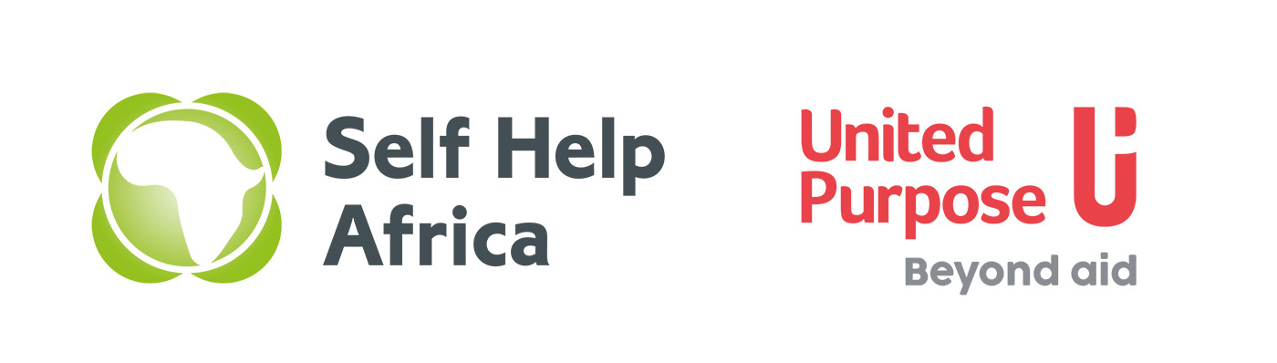
UP / SHA Vacancy

Programme Development Manager (Gender Lead)

Background
In August 2021 United Purpose (UP) and Self Help Africa (SHA) merged at a Global Level. In Malawi the country programmes have merged together under one organogram and all Lilongwe core teams are working together in one office at Mwai House next to Anamwino House in City Centre.

The merger of United Purpose and Self Help Africa has given us a unique opportunity to create an organisation built on our shared values and ideals and one that draws on our collective experience, knowledge and skills to expand and improve our work across the countries we work in. This is never more evident than in Malawi as it is also the only country where both UP and SHA were already implemented.

Job Purpose
The purpose of this post is to support the Deputy Country Director Programmes (DCD-P) and Country Director in reporting to donors, sharing and promoting project impacts, identifying funding opportunities and supporting the development of grant applications, and communicating effectively with partners and other stakeholders. The post holder will liaise with other UP/SHA country programmes/offices and the UK Office to ensure effective communication. They will support the Malawi UP/SHA team to ensure that the Malawi programme is sector leaders, adequately funded and positive donor and government relations are maintained.

The Programme Development Manager is responsible for providing support in establishing and monitoring continuous quality improvement, innovation, and quality assurance processes within UP/SHA Malawi and its programmes in order to improve internal processes, results delivery and accountability at various levels. S/he working with the Deputy Country Director – Programmes and the Grants and Compliance Manager will plan, direct or coordinate quality assurance programmes and formulate in-house quality technical standards, procedures and best practices across the project cycle in consultation within internal and external stakeholders and other benchmarks (for instance, in Safeguarding and Social Accountability) across the country programme. S/he will also be responsible for providing guidance and capacity for refining, strengthening and implementing a robust monitoring, evaluation, and learning (MEL) system at a country programme level and ensuring the integration and alignment of all programme and project M&E systems to this system. S/he will also build programme quality capacity throughout the country programme, ensure mechanisms are in place to share learning internally and externally, enable and promote a positive values based culture in UP, and provide guidelines in the promotion of learning methods and best practices across UP Malawi. S/he will be also responsible for promoting and mainstreaming gender equality and gender-based violence (GBV) awareness across all UP/SHA’s programmes in compliance with UP/SHA Malawi Gender Equality Strategy.

Responsible to: Malawi Deputy Country Director - Programmes
Base: Lilongwe, Malawi
Contract type: Initially 1 year fixed term contract, full time.

Programme Development
- Communicate and coordinate work relating to donor funding within the Malawi programme, including Lead on organising monthly pipeline meetings.
- Identify and support the development of new programmes and projects in line with quality standards (including safeguarding and gender) across SHA/UP Malawi’s strategy pillars.
- Identify opportunities and oversee the development of new programmes and projects to meet co-financing requirements.
- Support significant institutional and non-institutional proposal development, background research, coordination and draft writing;
- Work with project managers, Co-ordinators, partners and the finance colleagues in preparing and submitting proposals in line with the specific funding strategies;
- Ensure that the submission of proposals for all projects is coordinated with the relevant staff at project specific levels and with the Deputy Country Director-Programmes as appropriate.

Programme Quality

- Provide support to all programmes to review and edit all narrative reports to ensure quality standards on reporting to donors and wider stakeholders.
- Working with the DCD-P and the Grants and Compliance Manager support the roll-out of in-house programme quality procedures and standards as well as practical support tools, and monitor that these are upheld across the organisation - in line with national and international benchmarks and standards and UP/SHA policies, practices and values - particularly in WASH, agriculture, nutrition, M&E, gender, safeguarding, community engagement, facilitation and other programme management standards across the project cycle.
- Act as a catalyst for change and improvement in performance and quality – and promote an organisational culture of quality performance.
- Working with the DCD-P and the Grants and Compliance Manager monitor quality performance across programmes and operations, collect and feed data to the Management Team for regular review of programme and organisation impact.
- Promote a culture of learning, sharing and support to ensure quality programme delivery across the organisation

Reporting and Compliance
- Working with the Grants and Compliance Manager, advise and when necessary support Project Managers on donor guidelines and contractual obligations, particularly on reporting, co-funding, procurement and visibility requirements and work with the Deputy Country Director-Programmes to ensure a coordinated approach to donor grant management.
- Ensure timely reporting and communication on donor contracts and internal monthly reporting within SHA/UP;
- Support to ensure timely narrative and financial reporting to donors in collaboration with Project Co-ordinators and the Deputy Country Director-Programmes (including sending reporting reminders and proofing reports for quality and donor compliance).
- File all project documents (i.e. proposals, contracts, reports), liaise with the Global office to ensure copies are being shared and stored on salesforce
- Co-ordinate and maintain the monthly Project Status Summary Report and Project Summaries for the Global Office

Communication, networks, learning and dissemination of Best Practice:

- Produce communications, including brochures, case studies, project summaries, capacity statements, social media and website contents, as necessary. Supporting effective and timely programme visibility in line with SHA/UP strategies and donors and promote brand transition.
- Oversee and support the consolidation and finalisation of the monthly newsletter.
- Draft quarterly programme reports on behalf of the CP to be delivered to the Malawi Advisory Committee and the Global office SHA and UP Boards.
- Improve and produce documentation of lessons learned, best practices and case studies, and ensure wide scale dissemination and adoption. Build capacity of UP/SHA staff in report writing.
- Develop and disseminate best practice and lessons learnt documentation guidelines.
- Supporting identification and execution of appropriate innovations that contribute to changing the way things are done in the Malawi programme and ensure the lessons from the innovations are drawn and used accordingly.
- Leading the write up of the UP/SHA Malawi annual impact report in collaboration with the MEAL working group. This includes, if appropriate, facilitating learning reviews and document lessons for internal/external sharing and cross-learning.
- Represent SHA/UP at different coordination groups, forums, including RCCE cluster etc.
- Assist the Country Director in building donor relations and in attending meetings with donors as appropriate and required, and maintaining timely communication with donors in conjunction with Project Co-ordinators and Country Director.
- Identify, establish and maintain working relationships with local partners and relevant public institutions.

Qualifications:
- Bachelor’s degree / Master’s degree in a relevant field, such as International Development, International Relations
- At least 4 years of experience in project management, including previous experience in the development sector
- Previous grant management experience with institutional donors
- Fluency in English, both written and verbal; Outstanding proposal and report writing and proofreading skills
- Teamwork and team building skills, capacity building skills
- Extremely positive can-do attitude, ability to work independently and creatively in a multicultural context
- Solid planning and organisational skills
- Strong oral and written communication skills, analytical skills
- Ability to work efficiently under pressure and manage quickly shifting priorities and tight deadlines
- Good interpersonal skills with a patient, flexible & responsive disposition
- Ability to deal with sensitive issues in a discrete and diplomatic manner
- Strong personal passion and commitment to international development issues.

How to apply
Qualified and interested candidates who meet the stated requirements must submit a completed Application Form. Please note that CVs and cover letters will not be accepted.
Please visit https://united-purpose.org/s/UP-Job-Application-Form-2wtb.doc to download the Application Form, and then submit the completed form via email only to applicationsmw@united-purpose.org When submitting, please cite the position you are applying for in the subject title. Any applications that do not include this in the title will not be considered. Please also ensure that the application is saved as per the following example: [your name]_Programme Development Manager application. No hard copies / physical applications will be accepted.
Closing date for the receipt of completed application forms is 12:00 Midnight of Sunday, 26th June 2022. Only short-listed candidates will be contacted.
United Purpose / SHA takes the safety and well-being of all those we work with, and our staff, very seriously. We have a zero-tolerance policy on abuse. Our recruitment is safe, meaning that we recruit staff with the highest values and standards of ethical behaviour. United Purpose/ SHA has a Safeguarding Children and Vulnerable Adults Policy, which reflects our commitment to protecting the people with whom we work. All candidates will be expected to comply with this policy and its procedures.
For more information about UP/SHA, please visit our website at www.united-purpose.org/malawi/ or www.selfhelpafrica.org
UP/SHA is an equal opportunity employer. Female applicants are strongly encouraged to apply.

