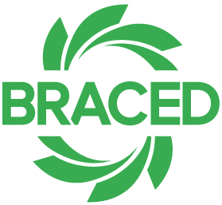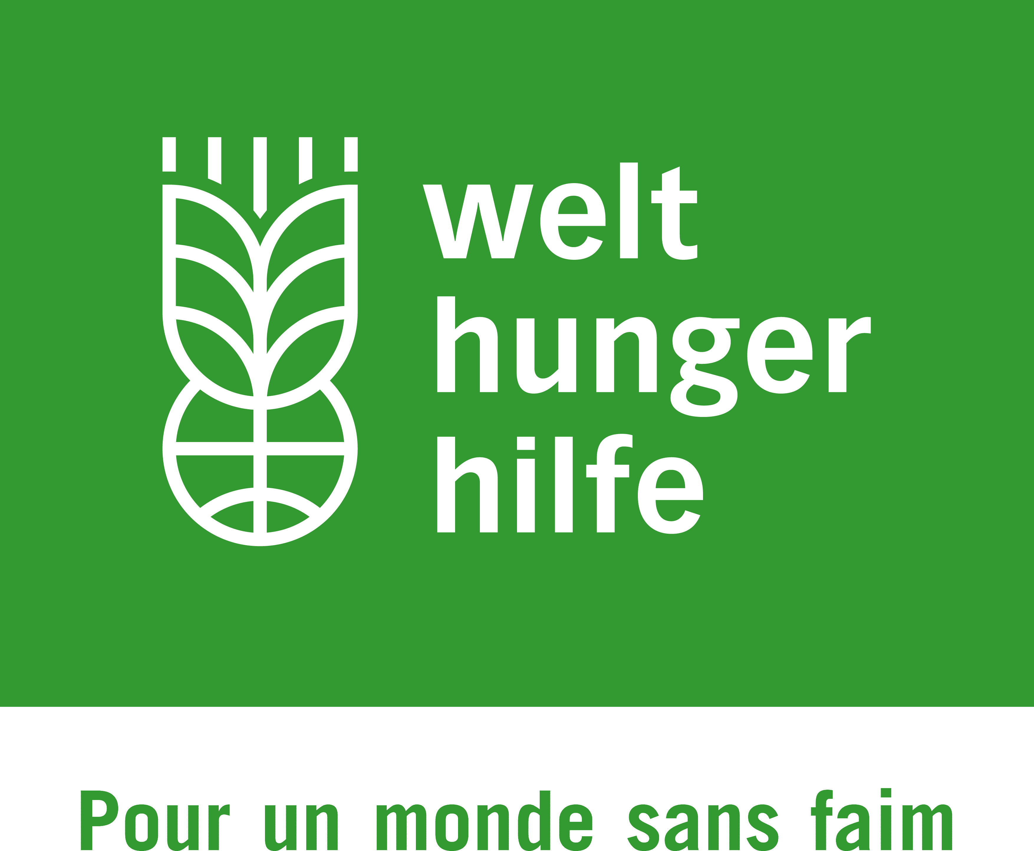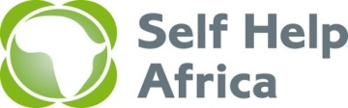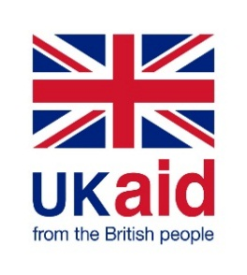

**Call for consulting services for the Final Evaluation of the BRES project in Burkina Faso**

Within the framework of the DFID-funded BRACED program, the consortium Welthungerhilfe / Self Help Africa (WHH/SHA) has since January 2015 implemented the BRES project in Burkina Faso. The project intervened in the Bam, Sanmatenga, Oubritenga and Kourwéogo provinces of the Central-Plateau and North-Central regions. The objective of the project is to strengthen the resilience of 620 000 men, women and children in the Central-Plateau and North-Central regions of Burkina Faso, to minimize their vulnerability to climate extremes and disasters. The project will come to an end on 31 March 2018.

For the Final Evaluation of the BRES project, which needs to be undertaken between 15 November 2017 and 25 February 2018, the consortium Welthungerhilfe / Self Help Africa seeks the services of a consultant to assist the project with a qualitative assessment of progress and outcomes achieved by the intervention, and with the elaboration of the evaluation report. Detailed terms of reference and an inception report which outlines the evaluation process, can be requested at the Self Help Africa, attention: Lorenza Quadrini, tel.: +353 1 677 8880; Email: [_lorenza.quadrini@selfhelpafrica.org](mailto:_lorenza.quadrini@selfhelpafrica.org)

The call for consulting services is open for all individual consultants and registered consulting firms. Proposals in English can be submitted in PDF format via email to Self Help Africa in Dublin at the following email address: [Lorenza.quadrini@selfhelpafrica.org](mailto:Lorenza.quadrini@selfhelpafrica.org)

The deadline for submission of proposals and supporting documentation is 17h00 on 19 October 2017. The consortium reserves the right to not award any contract in respect of this call for proposals.