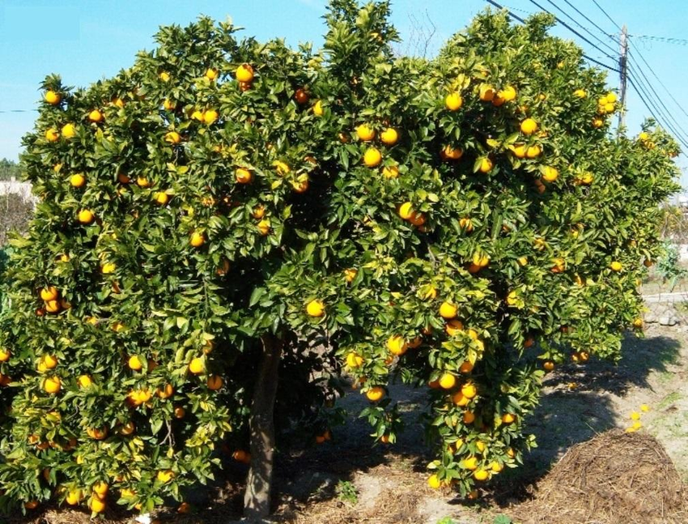

***Citrus sinensis***

***Self Help Africa planting in most African countries***

*Citrus sinensis* (dwarf orange) is a small, shallow-rooted evergreen shrub or tree about 6-13 m high with an enclosed conical top and mostly spiny branches. Twigs angled when young, often with thick spines

It is mostly grown for its fruits that are sold to earn income; the fruits are a good source of vitamin C; pulp, molasses, and residues from juice production are used as cattle feed; flowers are a source of nectar; its wood is a potential source of wood fuel; peels, leaves, and flowers contain fine essences of oils that may be used in manufacture of cosmetics and medicinal applications; extracts from leaves, roots, bark, and fruit extracts have medicinal value; and it provides shade and ornamental benefits.

This dwarf orange species is mostly grown as a food crop, or in an agroforestry system with shorter crops of cover crops.

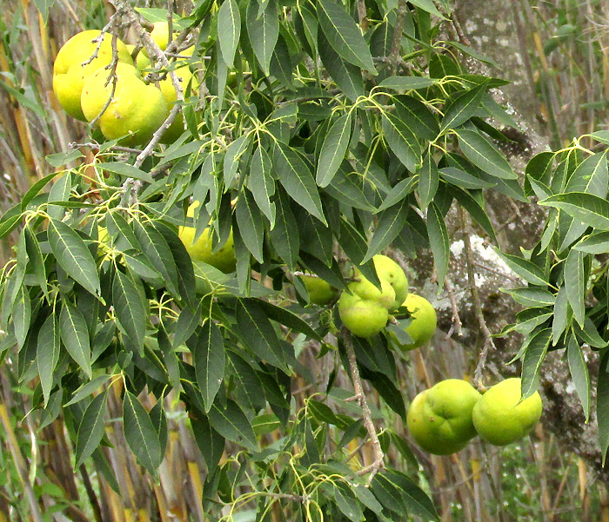

***Casimiroa edulis***

*Casimiroa edulis* (white sapote, white zapote, Mexican apple, Mexican sapote, casimiroa) originated from the highlands of Mexico and Central America now widely grown in the tropics. It is fairly drought resistant. It is an is an evergreen tree to 18 m tall, with spreading, often drooping branches and a broad leafy crown. Bark light-grey, thick and warty.

White sapotes are commonly grown from seeds and seedlings usually begin to bear fruit in 7-8 years. They occur both cultivated and wild and hence they can be propagated through assisted natural regeneration (ANR). Seed kernel extracts are poisonous/lethal bait for cockroaches; the fruit is eaten as dessert and the flavour is sweet with a hint or more of bitterness and sometimes distinctly resinous. Its wood is yellow, fine-grained, compact, moderately dense and heavy, medium strong and resistant, but not durable for long. This tree is planted as shade for plantations such as coffee. Extracts from the leaves, bark, and especially the seeds have been employed in the medicine industry as sedatives, soporifics and tranquilizers.

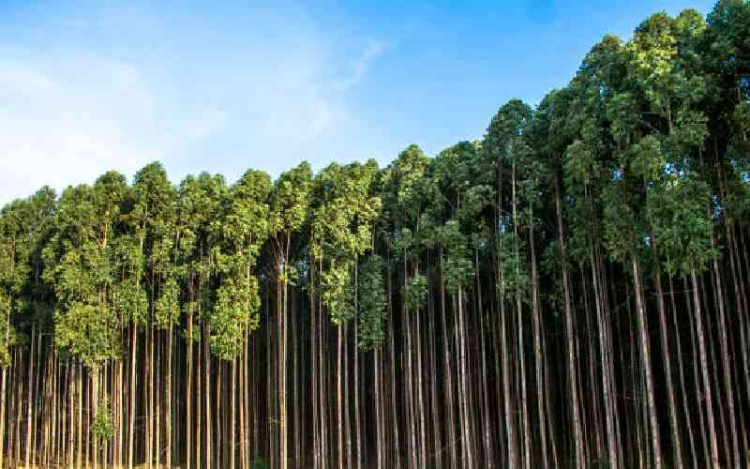

***DO NOT USE IN DIRECTORY***

***Eucalyptus* spp.**

***Self Help Africa planting is not commonly promoted due to their high-water consumption but are mostly planted in plantations, open spaces in forested areas***

Eucalyptus is one of three similar [genera](https://en.wikipedia.org/wiki/Genera) that are commonly referred to as "[eucalypts](https://en.wikipedia.org/wiki/Eucalypt)", the others being [Corymbia](https://en.wikipedia.org/wiki/Corymbia) and [Angophora](https://en.wikipedia.org/wiki/Angophora). Many species, though by no means all, are known as gum trees because they exude scribbly gum from any break in the [bark](https://en.wikipedia.org/wiki/Bark_(botany)). The generic name is derived from the [Greek](https://en.wikipedia.org/wiki/Ancient_Greek) words ευ (eu) "well" and καλύπτω (kalýpto) "to cover", referring to the [operculum](https://en.wikipedia.org/wiki/Operculum_(botany)) on the [calyx](https://en.wikipedia.org/wiki/Sepal) that initially conceals the [flower](https://en.wikipedia.org/wiki/Flower).

Due to their fast growth, the foremost benefit of these trees is their wood. They can be chopped off at the root and grow back again. They provide many desirable characteristics for use as [ornament](https://en.wikipedia.org/wiki/Ornamental_plant), timber, fuelwood and pulpwood. Eucalyptus wood is also used in a number of industries, from fence posts (where the oil-rich wood's high resistance to decay is valued) and charcoal to [cellulose](https://en.wikipedia.org/wiki/Cellulose) extraction for [biofuels](https://en.wikipedia.org/wiki/Biofuel). Fast growth also makes eucalypts suitable as [windbreaks](https://en.wikipedia.org/wiki/Windbreak) and to reduce [erosion](https://en.wikipedia.org/wiki/Erosion). Eucalyptus trees show [allelopathic](https://en.wikipedia.org/wiki/Allelopathic) effects; they release compounds which inhibit other plant species from growing nearby. Outside their natural ranges, eucalypts are both lauded for their beneficial economic impact on poor populations and criticised for being "water-guzzling" leading to controversy over their total impact.

***Jacaranda mimosifolia***

***Self Help Africa planting in Kenya, Uganda, Malawi, Zambia.***

*Jacaranda mimosifolia* (jacaranda, blue jacaranda, fern tree) is a deciduous tree up to 20 m in height with spreading branches making a light crown. Bark pale brown and furrowed, transverse cracks dividing the ridges between the furrows into long, narrow scales. The bole almost always short and malformed, and up to 40- 50 cm in diameter.

Trees are being planted in in forested areas, agroforestry systems, plantations, boundaries, homesteads

This species’ relatively large flowers easily attract bees; therefore, it is suitable for bee forage. Extracts from its leaves, bark, and roots have medicinal value. The tree creates pleasant open shade and can be used effectively as a screen or as a windbreak. The finely cut foliage is attractive adding to its flowers’ ornamental value.

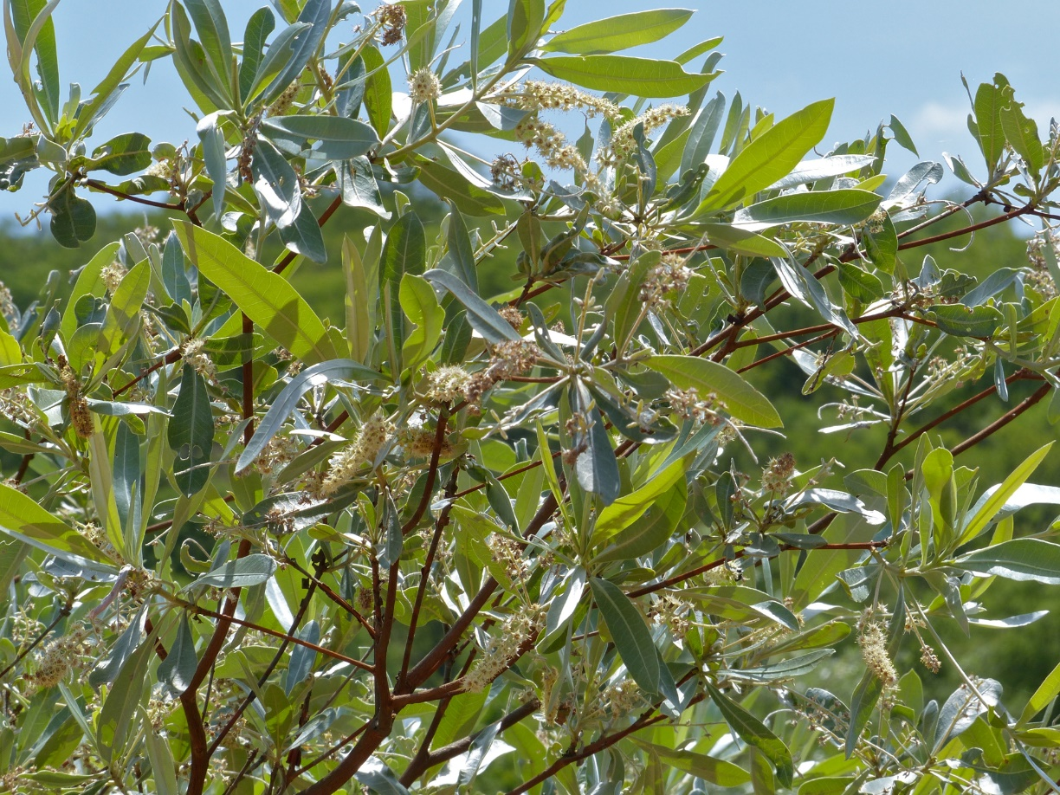

***Terminalia sericea***

***Self Help Africa planting in Zambia, Malawi, Mozambique.***

Also known as *‘Mpululu’* Terminalia sericea(silver terminalia) is a small, well-formed deciduous tree, 3-16 m with spreading branches to a light rather flat crown. It’s bark dark grey or grey brown, rather rough with longitudinal fissures; branchlets with characteristic purplish bark peeling off in strips, pale below; simple leaves clustered towards the tips of branchlets, 5-12 cm long, narrowed to the base, pale green, leathery, with silvery silky hairs below. Young leaves pink and dying leaves deep pink before they fall; flowers are cream to pale yellow, in short spikes to 5 cm; buds are silky hairy, opening with new leaves; and fruits pink purple-brown, to 4 cm long, oval and flat, winged around the central seed, tip notched.

The tree occurs in Brachystegia woodland and wooded grasslands, especially on sandy soils, between 450-1,300 m. It can be propagated using seedlings or root suckers Uses include medicine from leaves and roots, bee forage (flowers), rope from bark , red dye also from the bark.

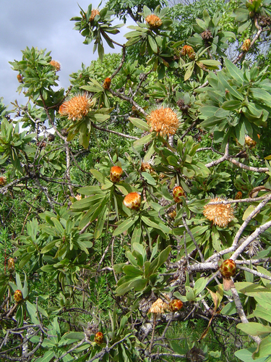

***Protea welwitschia***

***Self Help Africa planting in Uganda, Malawi, Mozambique, Zambia.***

*Protea welwitschia* (cluster-head sugar brush, dwarf savanna sugar brush) grows as a spreading, multi-stemmed [shrub](https://en.wikipedia.org/wiki/Shrub) or small, gnarled, bushy [tree](https://en.wikipedia.org/wiki/Tree). In tropical [East Africa](https://en.wikipedia.org/wiki/East_Africa) and [Zambia](https://en.wikipedia.org/wiki/Zambia) it grows to 1–3 metres, exceptionally 5 metres in height. In its shrub form it may have an underground bole or rootstock, from which the branches arise. The trunk grows to 30 centimetres in diameter at the base. It is gnarled, and covered in an irregularly fissured, brown-black bark. The young stems are covered in a brown woolly hairs.

The adult plant can survive the periodic [wildfires](https://en.wikipedia.org/wiki/Wildfire) that burn through its habitat by re-sprouting from the underground bole and hence considered among landscape conservation tree species. It also acts as a windbreak, used for its ornamental value, and its flowers are good bee forage.

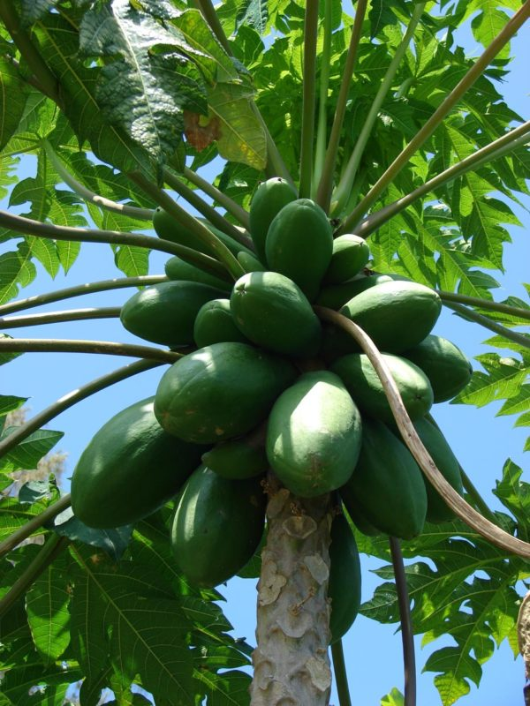

***Carica papaya***

***Self Help Africa planting on-farm in most countries as a food source***

*Carica papaya* (pawpaw, papaya) is a is an evergreen, tree-like herb, 2-10 m tall, usually unbranched, although sometimes branched due to injury, containing white latex in all parts. Stem cylindrical, 10-30 cm in diameter, hollow with prominent leaf scars and spongy-fibrous tissue. Has an extensive rooting system.

Green papaya fruit is cooked as a vegetable. Ripe papaya fruit is a breakfast and dessert fruit that can used to make fruit salads, refreshing drinks, jam, jelly, marmalade, candies, and crystallized fruit. Young leaves are sometimes eaten. Other uses: Papain, a proteolytic enzyme present in the latex from green fruit is extracted to be used in beverage, food and pharmaceutical industries. It is also used in bathing hides, degumming silk and softening wool. Carapine, an alkaloid present in papaya, has medicinal value. The fruit and juice are eaten for gastrointestinal ailments; a fresh leaf cataplasm is used to treat sores.

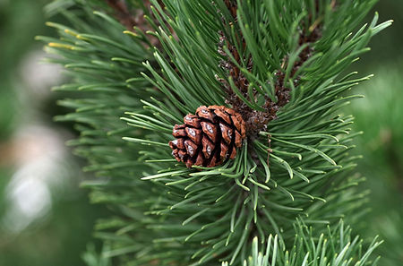

***Pinus spp.***

***Self Help Africa planting in several African countries***

*Pinus spp.* (pine) trees are [evergreen](https://en.wikipedia.org/wiki/Evergreen), coniferous [resinous](https://en.wikipedia.org/wiki/Resin) [trees](https://en.wikipedia.org/wiki/Tree) (or, rarely, [shrubs](https://en.wikipedia.org/wiki/Shrub)) growing 3–80 metres tall, with the majority of species reaching 15–45 m tall. Pines may be found in a very large variety of environments, ranging from semi-arid desert to rainforests, from sea level up to 5,200 m, from the coldest to the hottest environments on earth. They often occur in mountainous areas with favorable soils and at least some water.

These trees are planted and growing in a wide range of forest and savanna habitats, scattered in fire-prone grassland and woodland, and plantations.

Pine trees are beneficial to the environment since they can remove carbon dioxide from the atmosphere. Pine [pollen](https://en.wikipedia.org/wiki/Pollen) may play an important role in the functioning of [detrital](https://en.wikipedia.org/wiki/Detritivore) [food webs](https://en.wikipedia.org/wiki/Food_web). Nutrients from pollen aid detritivores in development, growth, and maturation, and may enable fungi to decompose nutritionally scarce litter. Pine needles are food to mesofauna to microfauna.