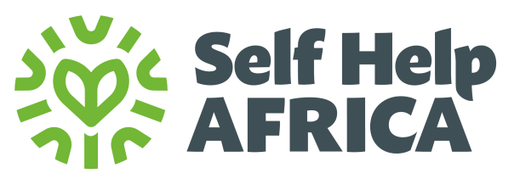

CONSULTANCY CALL
Self Help Africa (SHA) is an international NGO dedicated to the vision of an economically thriving and resilient rural Africa. We have 50 years of experience working with smallholder farmers, farmer associations, cooperatives and agribusinesses across Africa to help farmers grow and sell more food, improve diets, diversify incomes and make their livelihoods more sustainable and resilient to external shocks. SHA also builds awareness of issues affecting smallholders and represent their interests at policy and institutional level.
SHA is a core member of The Gorta Group which is composed of a group of innovative organisations driving sustainable economic and social change across Africa. Comprising Self Help Africa, United Purpose, Partner Africa and TruTrade, the Gorta Group combines expertise in market-based solutions to poverty and rural development; climate change mitigation and resilience; trade facilitation and farmer and worker rights; underpinned by an inclusive ethos that specifically targets women and youth.
Self Help Africa in partnership with the Food and Agriculture Organization of the United Nations and with funding support from the Embassy of the Kingdom of Netherlands in Uganda has been implementing a project in Kiryandongo refugee hosting districts. The project is being implemented in 6 clusters (G, C, D, I, J, P) in Kiryandongo refugee settlement for the refugee households and 3 sub-counties of Mutunda, Nyamahasa, and Kigumba respectively for the host communities. The project intends to strengthen the capacity of 433 refugee and 367 host community households to engage in market-oriented production of passion fruits and food crops to improve food and nutrition security, income, and livelihood.
Using the Farmer Field School (FFS) approach, the target households were trained on good agricultural practices in the selected value chains to boost their productivity and quality of produce. The training was complemented with the provision of agricultural inputs such as quality staple crops and vegetable seeds, grafted passion fruit seedlings, and basic farm tools using an electronic voucher scheme to enhance production. Furthermore, selected farmer groups were supported to access water for production infrastructures and trained on the use and management of these systems through the establishment of water user committees to promote climate-sensitive agricultural production
CONSULTANT FOR CONDUCTING A DOCUMENTARY FOR IMPROVING NUTRITION SECURITY, INCOME AND LIVELIHOODS OF SUBSISTENCE AND SMALL HOLDER FARMERS THROUGH THE DEVELOPMENT OF INCLUSIVE RESILIENT AND SUSTAINABLE FOOD SYSTEMS IN KIRYANDONGO

Specific objectives/scope of tasks for the consultant

- To document 2 case studies and best practices about the project
- To document 5 impact stories related to the project
- To Provide clear short talking videos about the project
- To Capture good action-oriented photos showing the different components of the project

The Terms of Reference for the assignment can be downloaded at https://selfhelpafrica.org/ie/category/tenders Qualified candidates should submit technical and financial proposals by E-mail as follows: -
procurement-uganda@selfhelpafrica.net
Please type “Consultant / Conducting a documentary for improving nutrition income and livelihoods UGK6 - [your consultant(s)/Consultancy firm name]” in the subject line of the e-mail.

The closing date for receiving the applications is no later than Close of Business on Tuesday 29th October 2024
Please do not send certificates at this stage. Due to the anticipated high volume of applications, kindly note that only shortlisted applications will be contacted.

Self Help Africa is an equal opportunities employer
Self Help Africa is completely against fraud, bribery and corruption. Self Help Africa does not ask for money for bids. If approached for money or other favors, or if you have any suspicions of attempted fraud, bribery or corruption please report this immediately by email to selfhelpafrica@expolink.co.uk. Please provide as much detail as possible with any reports.

