

**VACANCY ANNOUNCEMENT**

Self Help Africa (SHA) is an International Non-Governmental Organization (NGO) dedicated to the Vision of an economically thriving and resilient rural Africa. We have over 50 years of experience working with small holder farmers , Farmer associations , Cooperatives and their livelihoods more sustainable and resilient to external shocks. SHA also builds awareness of issues affecting smallholders and represent their interests at policy and institutional level. SHA is a core member of the Gorta across Africa , Comprising of Self Help Africa , United Purpose, Partner Africa and TruTrade, The Gorta Group combines expertise in the Market based solutions to poverty and rural development , Climate change mitigation and resilience ; trade facilitation and farmer farmer and worker rights; underpinned by an inclusive ethos that specifically targets women and youth. Self Help Africa Uganda urgently seeks to recruit a suitable candidate to fill the position of Finance Officer.

**Finance Officer (1 position) (Based in Kampala**

The Finance Officer is responsible for day to day accounting transactions including bookkeeping, cash accounts, monthly financial reports and bank reconciliations. The Finance Officer establishes and maintains efficient financial systems and control mechanisms to support the smooth running of the operations and ensure compliance with financial rules and procedures.

**Key areas of responsibilities include:**

1. Finance and Accounting

**The Job Descriptions for the position is below**

Please visit our website at <https://selfhelpafrica.org/ie/category/careers/> to apply for the position.

**The closing date for receiving applications is not later than close of business Tuesday, 2nd July, 2023.**

Please do not send certificates at this stage. Due to the anticipated high volume of applications, kindly note that only shortlisted candidates will be contacted.

**Self Help Africa is an equal opportunities employer**

Self Help Africa is completely against fraud, Bribery and Corruption . Self Help Africa does not ask for money for bids . if approached for money or other favour or if you have any suspicions of attempted fraud, Bribery or corruption , Please report this at selfhelpafrica.ethicspoint.com. Please provide as much detail as possible with any reports.

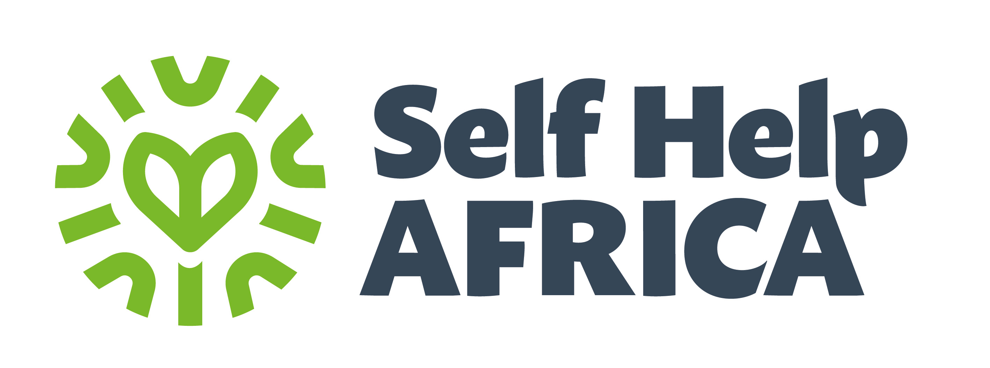

**JOB DESCRIPTION**

|  |  |
| --- | --- |
| **Job Title:** | Finance Officer |
| **Company:** | Self Help Africa / United Purpose |
| **Location:** | Kampala |
| **Contract type:** | Fixed Term |
| **Hours:** | 40 |
| **Reports to:** | **Head of Finance and Administration** |
| **Organisation overview:** | **About Self Help Africa & United Purpose**  In late 2021 Self Help Africa (SHA) and United Purpose (UP) merged. The two organisations – one headquartered in Ireland and the other in Wales – implement projects to end extreme hunger and poverty.  This merger doubled our size and reach – and means that in 2022 we are implementing poverty eradication projects in 17 countries, mainly in sub-Saharan Africa. Collectively, we are also part of a group that includes social enterprise subsidiaries Partner Africa, TruTrade and Cumo Microfinance.  In 2022 our work will reach more than six million people and invest upwards of €45m in more than 100 development programmes designed to improve food systems, facilitate access to markets and financial services, combat climate change, gender inequality, and improve access to clean water, sanitation and hygiene.  This is an exciting time to join us as we unite two like-minded and entrepreneurial organisations seeking to tackle the global challenges in progressive and innovative ways. |
| **Job Purpose:** | Reporting directly to the Head of Finance and Administration, the Finance Officer is responsible for day to day accounting transactions including bookkeeping, cash accounts, monthly financial reports and bank reconciliations. The Finance Officer establishes and maintains efficient financial systems and control mechanisms to support the smooth running of the operations and ensure compliance with financial rules and procedures. |
| **Key Responsibilities** | **Responsibilities (R) and Activities** |
| **Finance and Accounting:**   * Oversee and guide integrated financial management and reporting. * Assess, review, and ensure application of finance-related policies, instructions, procedures, etc. * Provide advice to management regarding the application of financial policies and procedures and, when necessary, coordinate with the Head of Finance and Administration, as applicable, regarding the interpretation of such policies and procedures. * Ensure accounting records are correct and reliable, including and not limited to timely bank reconciliations, maintenance of open items, timely processing of travel financial transactions, clearance of residual requisitions and purchase order balance. * In close coordination with the Head of Finance and Administration, support the preparation and review of donor financial reports, and endorse such reports before submission to donors. * Post in PSF Payment vouchers for both Mobile Money and Bank Accounts, Intercompany payments, fuel reconciliation & expenditure, staff accountabilities, Partner accountabilities, petty cash, prepayments schedule allocating costs to budget * Ensure monthly and yearly closing and other periodic accounting-related processes within his/her scope of responsibilities are executed in a timely and accurate manner. * Ensure the maintenance and on-going validity of the Delegation of Authority Plan. * Process of payments, ensuring that all relevant documents are attached and duly approved, e.g. invoices, delivery notes, goods received notes, credit notes, purchase order/ contracts, quotation analysis, quotations, demand forms etc. * Ensure that payments made are timely and accurate, and applicable month-end and year-end cut-off processes are implemented in line with relevant guidance. * Supervise the preparation of financial performance reports, monitoring expenditures with respect to approved budgets and work plans. * Ensure that local bank account administration and associated cash management functions are performed in adherence to financial guidelines. * Perform financial management and control related to Cash-Based Interventions in adherence to financial guidelines. * Review and certify vouchers and project disbursements. * Perform project control functions for the implemented activities. * Perform physical verification of Assets at least once per year to ensure that all assets are accurately recorded. * Oversee achieving of financial documents to safeguard financial records and audit trials. * Review monthly payroll and all the related statutory returns; compute staff separation benefits and ensure periodic Statutory returns are done to ensure adherence to the approved SHA policies, Employment and Tax Laws. * File all relevant statutory deductions before the deadline WHT, PAYE, NSSF, etc. * Liaise with respective program and project to assess the financial management of specific partners. * Assist HoFA in conducting financial training programs for partners involved in the implementation of SHA projects. * Support Audit processes * Coordinate, review and endorse responses to audit queries from internal and external audits and work with the Head of Finance and Administration to ensure the implementation of accounting audit recommendations. * Support implementation of strategies and initiatives relating to financial management, internal controls and strengthening of financial management capacity at SHA. * Assist with other finance and accounting related projects / tasks as assigned. |
| **Qualifications/Other Requirements:** | **Essential**   * A Bachelor’s Degree in Accounting, Finance, Business Administration, or a related field. * A professional certification (e.g., CPA, ACCA) or related certification is preferred. * At least 5+ years of experience in a finance or accounting role. * Strong technical abilities and up to date knowledge of Generally Accepted Accounting Principles. * Excellent communication abilities to explain financial data. * Fluency in spoken and written English. * Ability to bring accounts to at least Trial Balance stage.   **Desirable**   * Experience in the preparation and review of management accounts and the critical analysis of a Trial Balance. * Experience in the preparation of annual financial statements for audit. * Willingness to travel nationally and internationally. * Experience of working with partner organisations. * Experience of working with donor funds. * Experience of and supporting staff. |
| **Key relationships:** | **Internal**   * Country management team * Senior Finance Accountant, Finance and Administration Officer and the Country Office staff team * Project Managers   **External**   * Partners, Banks, external auditors and other service providers |
| **Most Critical Proficiencies:** | * Excellent verbal, analytical, organisational and written skills * People management skills * Proactive and motivated with a strong commitment to Self Help Africa’s vision, mission and values * Excellent ICT skills including a good knowledge of MS Office and accounting software * Attention to detail and the ability to produce timely and accurate financial reports |

*All candidates offered a job with Self Help Africa/United Purpose will be expected to sign our Safeguarding Policies and Code of Conduct as an appendix to their contract of employment and agree to conduct themselves in accordance with the provisions of these documents. Specific roles may require Police/DBS/ [relevant police authority] vetting.*

**Self Help Africa/United Purpose strive to be an equal opportunities employer.**