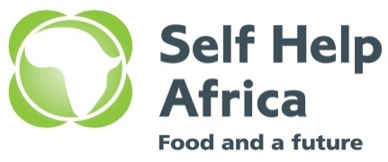
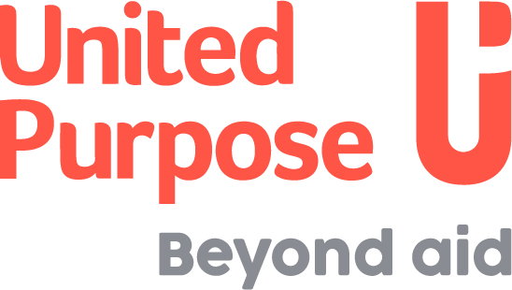

VACANCY

ENUMERATOR/ RESEARCH ASSISTANT/ DATA ENTRY CLERK

In August 2021, United Purpose and Self-Help Africa (UP/SHA) merged at a Global Level. In Malawi the country programmes have merged under one organogram. The merger of United Purpose and Self-Help Africa has given us a unique opportunity to create an organisation built on our shared values and ideals and one that draws on our collective experience, knowledge, and skills to expand and improve our work across the countries we work in.

While implementing its 2023-2027 strategy, the organisation will be conducting research studies/ surveys as a way of building evidence and understanding the impact of our work. With the foregoing, the organization would like to engage the services of well qualified and experienced individuals to work as temporary enumerators, research assistants and data entry clerks for various projects across the country. The intent would be to identify a list of suitable candidates who would be given a framework contract outlining expected responsibilities and remuneration, and who would then be called upon and paid on a daily basis when their services are required.

- DUTIES AND RESPONSIBILITIES
Duties and responsibilities will vary depending on the assignment/project needs, as will the exact tools and methods you will be asked to implement under the framework contract. Your responsibilities will vary, but are likely to include, but are not limited to:

- Data Collection
- Data collection using a household questionnaire using KoBo Collect mobile application or similar data collection tools.
- Downloading new forms and submitting completed ones onto the tablets using KOBO collect
- Data collection using FGDs, and any other PRA tools as provided and requested by the supervisors.
- Preparation of focus group discussion summaries from focus group discussions
- Ensure data is correctly filled in the questionnaire and all other tools used.
- Ensure completed/filled data collection tools are complete and submitted to the supervisor as per field guidelines.
- Preparation and submission of field reports to supervisors
- Conduct sensitisation and mobilisation of survey participants.
- Performing any other duties assigned by the research supervisors from time to time.

- Data Entry
- In consultation with the project, prepare tools for data entry in the appropriate software in consultation with the program/ project’s teams.
- Conduct data verification focusing on completeness and accuracy from the data collection tools/ forms.
- Perform data entry using a prescribed data entry tool.
- Perform preliminary data cleaning by flagging outliers to the supervisor.
- In case of qualitative data, transcribe data from the FGD notes and interview recordings.

- QUALIFICATIONS
- Minimum of bachelor’s degree in Agricultural Sciences, Natural Resources Management, Environmental Sciences, Business Administration, Communication Studies, Community Development Studies, ICT/ MIS/ Data Management related fields, Social Sciences/ Research related fields or any other qualification relevant to Self Help Africa/ United Purpose work. Those with relevant Diplomas and desirable experience shall be considered.
- Proven experience in data collection using surveys and other research methodologies.
- Proven experience in data collection using qualitative and quantitative tools i.e., FGDs, KIIs, and structured questionnaires.
- Previous experience working with UP/SHA is an added advantage.
- Experience using mobile technologies or online data collection applications such as KoBo.
- Experience in data entry using Excel, Access Database, SPSS, STATA, EPI-Infor etc.
- Must be willing to travel and conduct research in the hard-to-reach areas.

How to apply
Qualified and interested candidates who meet the stated requirements must submit a completed Application Form. Please submit the completed form via email only to applicationsmw@united-purpose.org

When submitting, please cite the position you are applying for in the subject title and the following should be included; Cover letter, CV and Copies of Certificates saved in your name. Any applications that do not include these will not be considered.
No hard copies / physical applications will be accepted. Please note zipped Folder will not be accessed.

Closing date for the receipt of completed application forms is 12:00 Midnight of 31st May, 2023

United Purpose/Self Help Africa takes the safety and well-being of all those we work with, and our staff, very seriously. We have a zero-tolerance policy on abuse. Our recruitment is safe, meaning that we recruit staff with the highest values and standards of ethical behaviour. United Purpose has a Safeguarding Children and Vulnerable Adults Policy, which reflects our commitment to protecting the people with whom we work. All candidates will be expected to comply with this policy and its procedures.

For more information about the organisation, please visit our website at www.united-purpose.org/malawi/ www.selfhelpafrica.org/ie/malawi/
UP /SHA is an equal opportunity employer.

