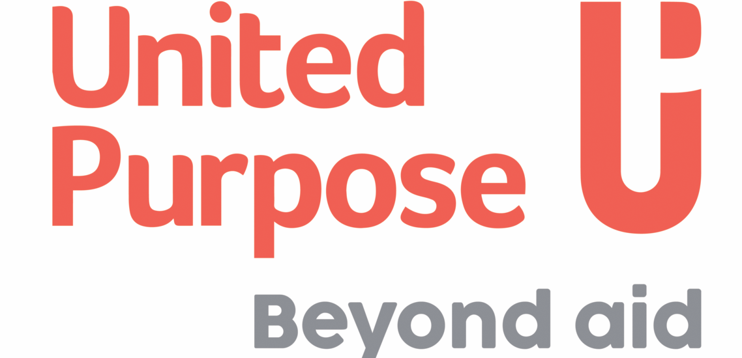

JOB DESCRIPTION
Job Title: | Driver
Company: | Self Help Africa / United Purpose
Location: | Adjumani
Contract type: | Fixed Term
Hours: | 40
Reports to: | Project Manager
Organisation overview: | About Self Help Africa & United Purpose  In late 2021 Self Help Africa (SHA) and United Purpose (UP) merged. The two organisations – one headquartered in Ireland and the other in Wales – implement projects to end extreme hunger and poverty.  This merger doubled our size and reach – and means that in 2022 we are implementing poverty eradication projects in 17 countries, mainly in sub-Saharan Africa. Collectively, we are also part of a group that includes social enterprise subsidiaries Partner Africa, TruTrade and Cumo Microfinance.  In 2022 our work will reach more than six million people and invest upwards of €45m in more than 100 development programmes designed to improve food systems, facilitate access to markets and financial services, combat climate change, gender inequality, and improve access to clean water, sanitation and hygiene.  This is an exciting time to join us as we unite two like-minded and entrepreneurial organisations seeking to tackle the global challenges in progressive and innovative ways.
Job Purpose: | The purpose of the job is to drive staff and to manage the project vehicle for Self Help Africa
Key Responsibilities | Responsibilities (R) and Activities
- Drive the project vehicles with strict adherence to local traffic laws and in accordance to project rules and regulations pertaining to vehicles
- Transport project staff and materials in Adjumani Town and the regions
- Maintain the vehicle in a satisfactory condition, including weekly cleaning of the interior and exterior and periodic (quarterly) cleaning of the motor and chassis.
- Ensure that tyres are in good working conditions at all time, and that spare tyre is in good condition
- Ensure that vehicle usage log is updated on a daily basis and submitted on a monthly basis.
- Ensure that fuel consumption report is submitted as required.
- Ensure regular maintenance of the vehicle, and that fluids (water, oil, fuel, washer liquid, etc.) levels are at required levels
- Report any apparent malfunction to the Supervisor.
- Report any damage or accident to the Supervisor immediately.
- Ensure that the vehicle is safely parked and locked when not in use.
- Carry out project errands as required.
Qualifications/Other Requirements: | Essential:  - Must possess a UCE or UACE certificate  - Should have 5 years driving experience with preferably Non-Governmental organisations  - Must possess a valid driver’s license with preferably classes B,DL,CM
Most Critical Proficiencies: | - Knowledge of driving rules and regulations and skills in minor vehicle repairs. Knowledge of email, telephone and other applications.  - Trustworthy, high sense of responsibility, alertness; physical fitness on duty, emotional stability, neat and courteous.  - Good knowledge of the Project activity areas and the current conditions of roads and highways.  - Ability to deal patiently and tactfully with people of different national and cultural backgrounds.  - Flexibility to fit into often changing priorities  - Ability to fluently communicate in both verbally and written language(s) applicable to project requirements

All candidates offered a job with Self Help Africa/United Purpose will be expected to sign our Safeguarding Policies and Code of Conduct as an appendix to their contract of employment and agree to conduct themselves in accordance with the provisions of these documents. Specific roles may require Police/DBS/ [relevant police authority] vetting.

Self Help Africa/United Purpose strive to be an equal opportunities employer.

