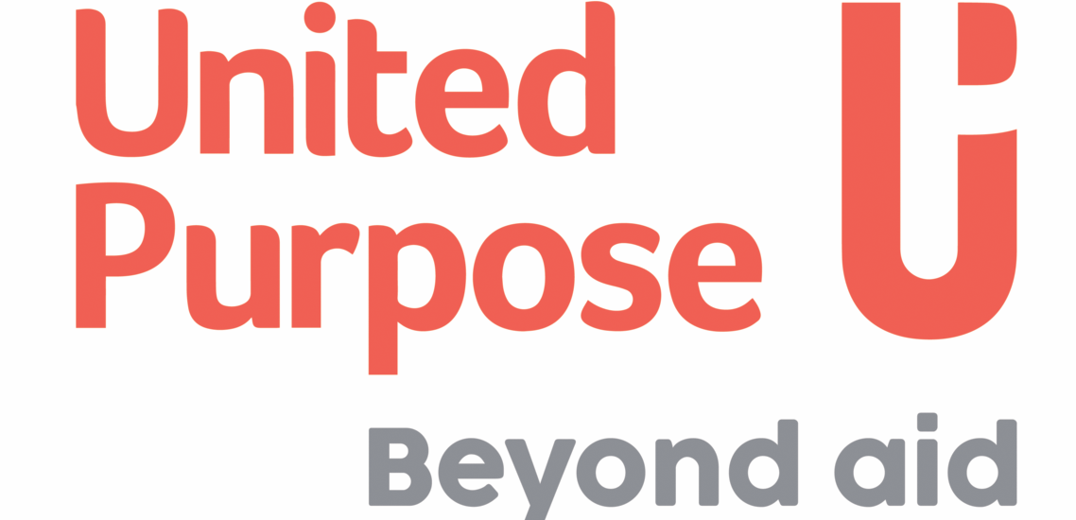

JOB DESCRIPTION
Job Title: | Office Manager CO
Company: | Self Help Africa / United Purpose
Location: | Kampala
Contract type: | Fixed Term
Hours: | 40
Reports to: | Operations and Finance Manager
Organisation overview: | About Self Help Africa & United Purpose  In late 2021 Self Help Africa (SHA) and United Purpose (UP) merged. The two organisations – one headquartered in Ireland and the other in Wales – implement projects to end extreme hunger and poverty.  This merger doubled our size and reach – and means that in 2022 we are implementing poverty eradication projects in 17 countries, mainly in sub-Saharan Africa. Collectively, we are also part of a group that includes social enterprise subsidiaries Partner Africa, TruTrade and Cumo Microfinance.  In 2022 our work will reach more than six million people and invest upwards of €45m in more than 100 development programmes designed to improve food systems, facilitate access to markets and financial services, combat climate change, gender inequality, and improve access to clean water, sanitation and hygiene.  This is an exciting time to join us as we unite two like-minded and entrepreneurial organisations seeking to tackle the global challenges in progressive and innovative ways.
Job Purpose: | To support Self Help Africa operations by maintaining office systems
Key Responsibilities | Responsibilities (R) and Activities | Results
 | R1: Management & Secretarial Tasks:  - Information management and communication  - Safety of company assets and records  - Secretarial services management  - Management of car pool and other travel arrangements  - Responsible for writing the minutes of the team meeting Finance Department  - Preparation of Public Relation materials and events with support of the appointed PR committee  - Serve as the point person for office manager duties including: the reception area, maintenance, mailing, equipment, bills, errands  - Fix appointments and when necessary, research for information according to the needs of the Country Office  - Follow up on all the rendez vous of the Country Director  - Place important notices on the main notice board | ●Maintain correct filling of documents  ●Ensure an efficient, respectable and pleasant reception area
 | R2: Book Keeping/Finances Tasks:  a. Ensure that petty cash expenditures are properly documented/supported  b. Prepare requisitions of office supplies/materials  c. Coordinate and monitor invoice preparation and payment for offices in the country  d. Inputting data into payments spreadsheet  e. Prepare necessary requests for funds prior to field travels of the Country Director  f. Provide support to the Department of Finance and Administration | ●Ensure Proper management of petty cash
 | R3: Store management:  a. Ordering and taking stock of office supplies  b. Ensuring records of all supplies are up-to-date and inflows balanced against outflows | ●Management of office supplies
Qualifications/Other Requirements: | Essential:  - Diploma in Secretarial Studies or any related field.
Key relationships: | Internal  - All Staff  External  - Visitors  - Vendors
Most Critical Proficiencies: | - Communication skills  - Management skills  - Information and records management skills  - Interpersonal skills  - Basic accounting skills  - Front office & customer care skills  - Leadership skills  - Basic knowledge of Private Sector operations

All candidates offered a job with Self Help Africa/United Purpose will be expected to sign our Safeguarding Policies and Code of Conduct as an appendix to their contract of employment and agree to conduct themselves in accordance with the provisions of these documents. Specific roles may require Police/DBS/ [relevant police authority] vetting.

Self Help Africa/United Purpose strive to be an equal opportunities employer.

